Project 2: Introduction to Numpy

John Wesley Mathis

Dr. Anthony Choi

June ##, 2024

ECE/SSE 591, Summer 2024

Table of Contents:

Deliverable Table 6

1. Introduction 7

2. Palindrome Generator Analysis 8

3. To-Do List Code Analysis 14

4. Guessing Game Code Analysis 20

5. Gain Calculator and File Storage Code Analysis 26

6. Python Semantics: Variables 31

7. Python Semantics: Operators 32

8. Built-In Scalar Types 34

9. Built-In Data Structures 35

10. Control Flow Statements 37

11. Defining Functions 38

12. Errors and Exceptions 39

13. Iterators 40

14. List Comprehensions 44

15. Generators and Generator Expressions 47

16. Modules and Packages 49

17. Strings and Regular Expressions 51

18. Conclusion 56

References 57

Table of Figures:

Figure 1.Palindrome Generator Example Python Code 8

Figure 2.Palindrome Generator: Obtaining user input numbers to display 9

Figure 3.Palindrome Generator: Obtaining user input for starting number 10

Figure 4.Palindrome Generator Example Output 11

Figure 5.Palindrome Generator Error Handling 12

Figure 6.Palindrome Generator Error Handling 12

Figure 7: Palindromic Generator: Output when user entered a negative number 13

Figure 8.Todo List Code 14

Figure 9: Todo List Code (continued) 15

*Figure 10.Todo List: Choosing Menu Option* 16

Figure 11.Todo List: Adding a Task 16

Figure 12.Todo List: Displaying Tasks 17

Figure 13.Todo List: Removing a task output 17

*Figure 14.Todo List: Error handling* 18

*Figure 15.Todo List: Error handling output* 18

*Figure 16.Todo List: Exiting program* 19

Figure 17: Todo List: Exiting program output 19

*Figure 18.Guessing Game code* 20

*Figure 19.Guessing Game code (continued)* 21

*Figure 20.Guessing Game: Example input for entering lower range* 22

*Figure 21.Guessing Game: Example input for entering upper range* 23

*Figure 22.Guessing Game: Example input for entering number of attempts* 23

*Figure 23.Guessing Game: Example output and input of entering a guess* 24

*Figure 24.Guessing Game: Example output after a bad guess* 24

*Figure 25.Guessing Game: Example output after losing* 25

*Figure 26.Gain Calculator code* 26

*Figure 27.Gain Calculator: Example prompting for input voltage* 27

*Figure 28.Gain Calculator: Example prompting for output voltage* 28

*Figure 29.Gain Calculator: Example showing repeated prompt for input voltage* 28

*Figure 30.Gain Calculator: Example showing repeated prompt for output voltage* 29

*Figure 31.Gain Calculator: Exiting program* 29

*Figure 32.Gain Calculator: Output* 30

*Figure 33.Python Semantics Variables: Conversion calculator code and output* 31

*Figure 34.Python Semantics Operators: Simple calculator code* 32

*Figure 35.Python Semantics Operators: Simple calculator output* 33

*Figure 36.Built-In Scalar Types: Simple calculator code and output* 34

*Figure 37.Built-In Data Structures: Movie collection code* 35

*Figure 38.Built-In Data Structures: Movie collection output* 36

Figure 39: Control Flow Statements code and output 37

*Figure 40.Defining Functions Code and Output* 38

*Figure 41.Errors and Exceptions code and output* 39

*Figure 42.Demonstrating `iter` function* 40

*Figure 43.Demonstrating iteration and enumeration code and output* 40

*Figure 44.Demonstrating `zip` code and output* 41

*Figure 45.Demonstrating `map` code and output* 42

*Figure 46.Demonstrating `filter` code and output* 43

*Figure 47.Basic list comprehension code and output* 44

*Figure 48.Nested list comprehension code and output* 45

*Figure 49.List comprehension structure with conditionals code and output* 45

*Figure 50.Dictionary comprehension code and output* 46

*Figure 51.Generator expressions code and output* 47

*Figure 52.Generator function code and output* 48

Figure 53: Package creation: Folder structure 49

Figure 54: Package creation: Functions within `stringops.py` 50

Figure 55: Package creation: Final code and output 50

*Figure 56.String manipulation code and output* 51

*Figure 57.Find and replace string manipulation code and output* 52

*Figure 58.`Split` and `Partition` methods code and output* 53

*Figure 59.Regular Expressions code* 54

*Figure 60.Regular expression output* 55

# **Deliverable Table**

The purpose of this table is to provide a complete view of the concepts covered in *"A Whirlwind Tour of Python"* (VanderPlas, 2016) and provide a general page location and/or project name for where the topic was demonstrated. This is not an exhaustive list. Many areas are covered by multiple projects. This is meant only as a means to show specific areas where the topic is demonstrated and to ensure that every area was covered.

|  |  |
| --- | --- |
| Deliverables | Location |
| Understanding Data Types in Python |  |
| The Basics of NumPy Arrays |  |
| Computation of NumPy Arrays: Universal Functions |  |
| Aggregations: Min, Max, and Everything In Between |  |
| Computation on Arrays: Broadcasting |  |
| Comparisons, Masks, and Boolean Logic |  |
| Fancy Indexing |  |
| Sorting Arrays |  |
| Structured Data: NumPy’s Structured Arrays |  |

# 1. Introduction

Python is a programming language that is known for its simplicity and versatility. Due to its easy to understand syntax, it has quickly grown to be a popular language in the data science community. With its extensive libraries for data manipulation and visualization, it serves as a powerful tool in various areas, including scientific research. The *"A Whirlwind Tour of Python"* (VanderPlas, 2016) provided a comprehensive, structured approach to learning Python’s fundamentals, providing a solid foundation for exploring more complex topics and use cases in data science.

This report documents my journey of learning the fundamentals of Python, including it’s syntax, semantics, and operations, and its relevance in scientific programming. As part of my learning process, I undertook a series of coding exercises and mini-projects aimed at reinforcing my understanding and practical skills in using Python.

This report is intended to demonstrate my proficiency in the Python topics covered by *"A Whirlwind Tour of Python"* (VanderPlas, 2016) such as variables, data structures, loops, conditionals, and functions, to name a few. Each exercise and mini-project serves as a case study to illustrate the utility of processing data in Python and its potential applications. Throughout this process, I faced several challenges from understanding complex concepts to debugging code errors. However, this provided an opportunity to improve my problem-solving skills.

All the code presented was written using VS Code with Jupyter Notebook extensions. In the following sections, I will present the mini-projects first, with each section labeled according to the name of the project. Four projects were coded, each demonstrating the fundamentals of the Python language. Explanations are provide to explore the structure and functionality of the code. The final sections of the report will delve into the exercises I completed while reading *"A Whirlwind Tour of Python"* (VanderPlas, 2016) and further studying through practices, tutorials, and discussions.

# 2. Palindrome Generator Analysis

The palindrome generator python script is the first practical application that covers several of the fundamental elements covered in *"A Whirlwind Tour of Python"* (VanderPlas, 2016). A palindrome is a word or number that can be read the same backwards and forwards, such as ‘101’. Figure 1 below provides the complete code for the program. Two functions are defined in the code demonstrating how to create and use functions to encapsulate logic and promote code reuse. The first function created is *`is_palindrome(num)`*. This function checks if a provided number is a palindrome. This functions accomplishes this by using string manipulation to convert the number entered to a string and then uses slicing to reverse it. A comparison is then used to determine if the string is the same backwards and forwards. The *`palindrome_num_gen(N=10)`* function uses the *`yield`* statement to create a generator function to produce an infinite sequence of palindromic numbers. The *`while True`* loop and *`if`* statements within the generator function illustrate control flow and the ability of the generator function to continue indefinitely. This script incorporates input from a user and uses the `try...except` block to handle invalid input. Another control flow statement is used to loop through the generator to print a specified number of palindromic numbers.

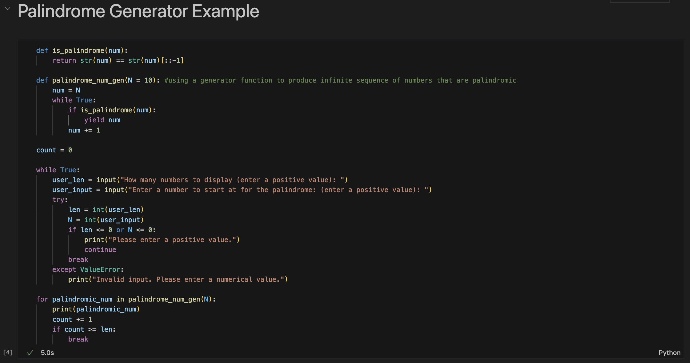

*Figure 1.Palindrome Generator Example Python Code*

This program incorporates input from the user to make it interactive by asking the user how many palindromic numbers they would like the program to display. Figure 2 demonstrates the program running and executing this line of code. Whatever the user inputs into the text box, is then stored in a variable labeled *`user_len`*. The user is then prompted to enter a number to start at to begin printing palindromic numbers. This value is stored in the variable *`user_input`*. Figure 3 displays the prompt that a user would see when running this program. After the user has entered input for both prompts, the *`for`* loop is then executed along with the functions to determine if a number is palindromic. The resulting values are then printed to the screen. Figure 4 below demonstrates example output if the user wanted to print twenty-two palindromic numbers to the screen starting with the number 235.

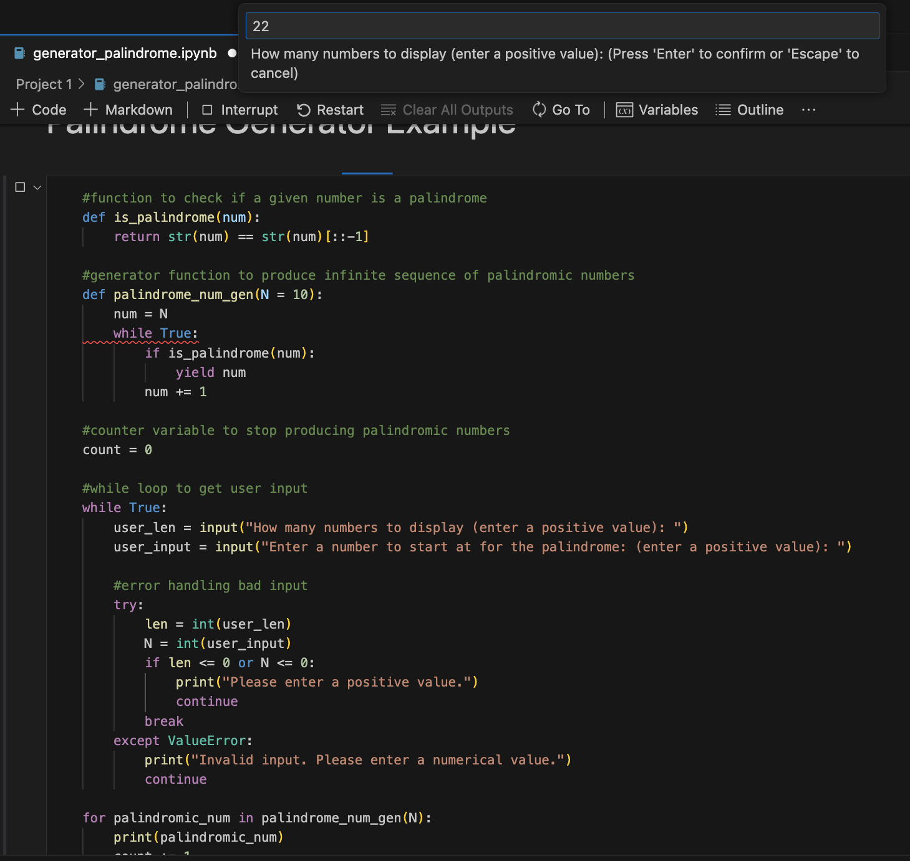

Figure 2.Palindrome Generator: Obtaining user input numbers to display

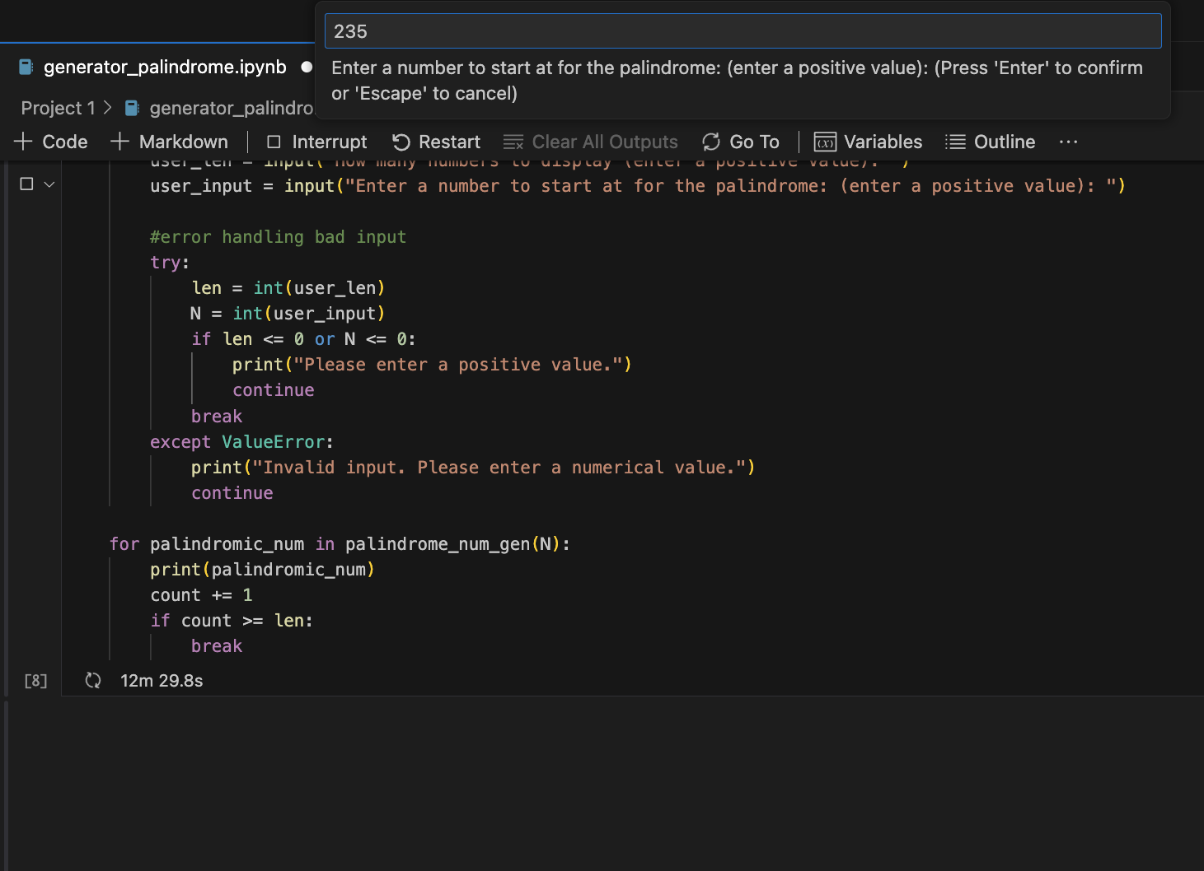Figure 3.Palindrome Generator: Obtaining user input for starting number

One of the problems encountered while creating this code was handling input from the user that was non-numerical. A *`try...except`* block was incorporated into the code to catch *`ValueError`* exceptions that are produced when the user would input a string, such as a word instead of a number, and the code would try to convert that word into a numerical value. Figure 5 below demonstrates the robustness of the code to provide information to the user that their input is invalid and they should enter a numerical value. Rather than the code just simply breaking, it starts at the beginning of the *`while`* loop prompting the user again for input, as demonstrated in Figure 6.

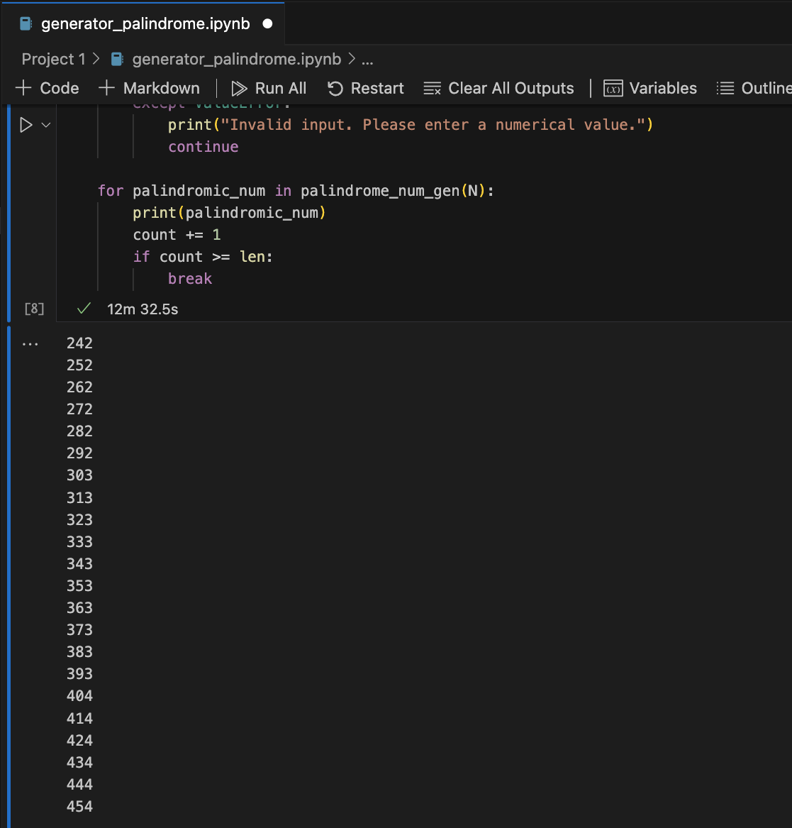Figure 4.Palindrome Generator Example Output

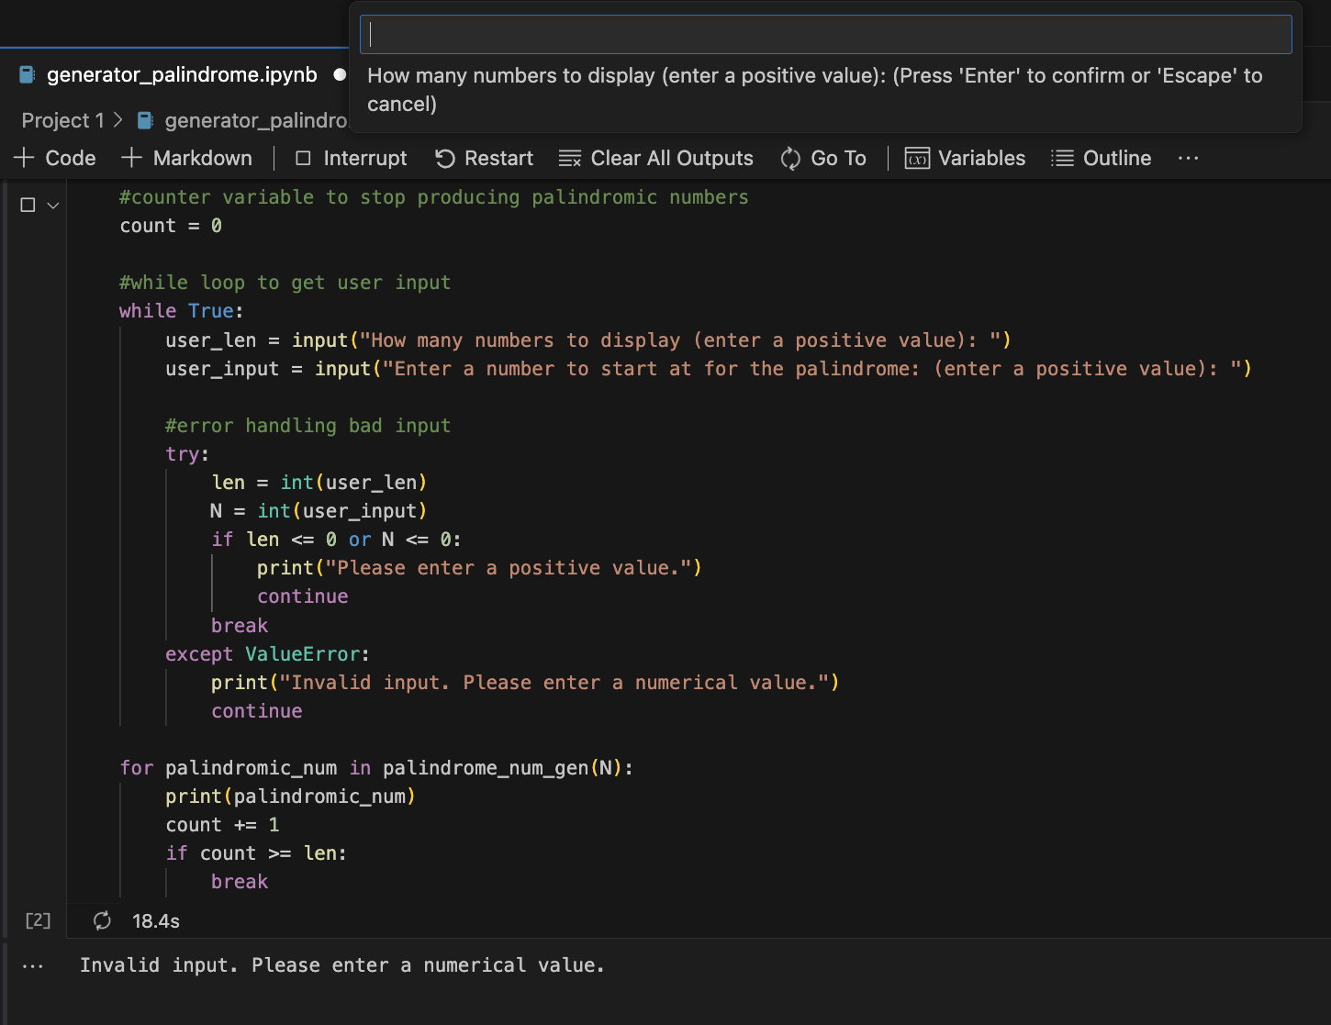

Figure 6.Palindrome Generator Error Handling

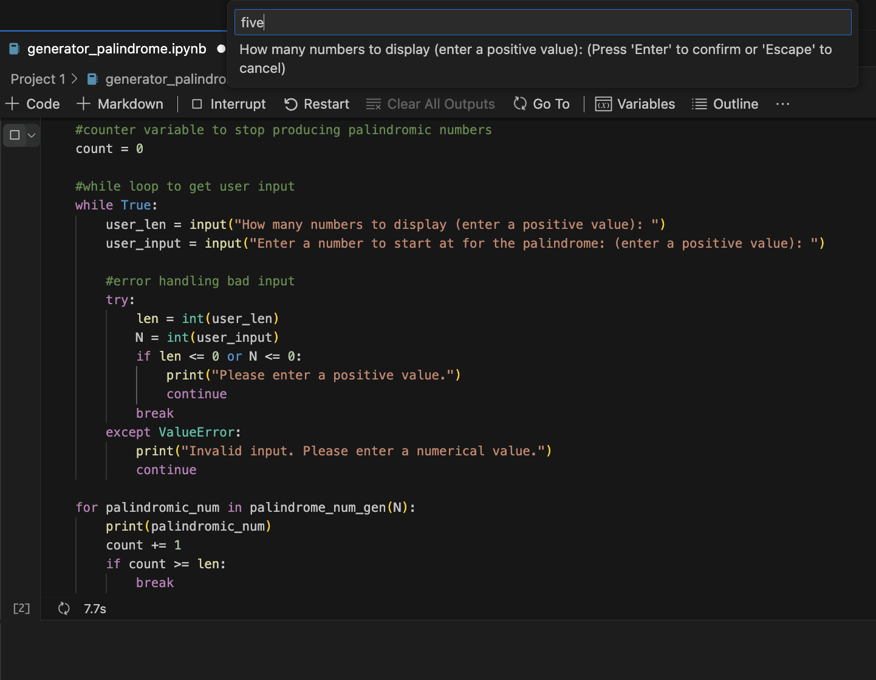

Figure 5.Palindrome Generator Error Handling

While designing this code, one other problem that was encountered was if the user entered a negative number as input. This led to unexpected behavior (see Figure 7). In order to produce expected results, an *`if`* statement was incorporated into the *`try`* block to determine if the number entered is positive. If the number is positive, the program continues as usual. However, if the number is negative, then the user is prompted to enter input again but to enter a positive value.

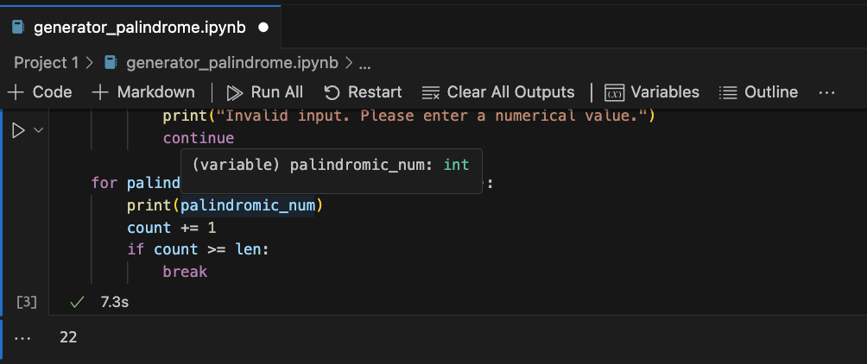Figure 7: Palindromic Generator: Output when user entered a negative number

# 3. To-Do List Code Analysis

This script provides a simple command-line based to-do list application. Figure 8 and 9 below display the entire code used to construct this example. This program allows the user to add, display, and remove tasks, along with an option to exit the program. The *`tasks`* list is used to store the tasks inputed by the user. Several functions were defined and used to perform operations on the list such as appending and removing elements from the *`tasks`* list. The program accepts user input and uses the `try...except` block to handle value errors for if the user tries to input a non-numeric value. A *`while True`* loop is used to keep the program running, allowing the user to continuously interact with the menu until the ‘exit’ option is chosen. An *`if`*` statement provides the ability to take the user input from the menu and execute different functions. An enumerate function was constructed to display the task indices when listing the tasks to help a user identify the task numbers easily and increase readability.

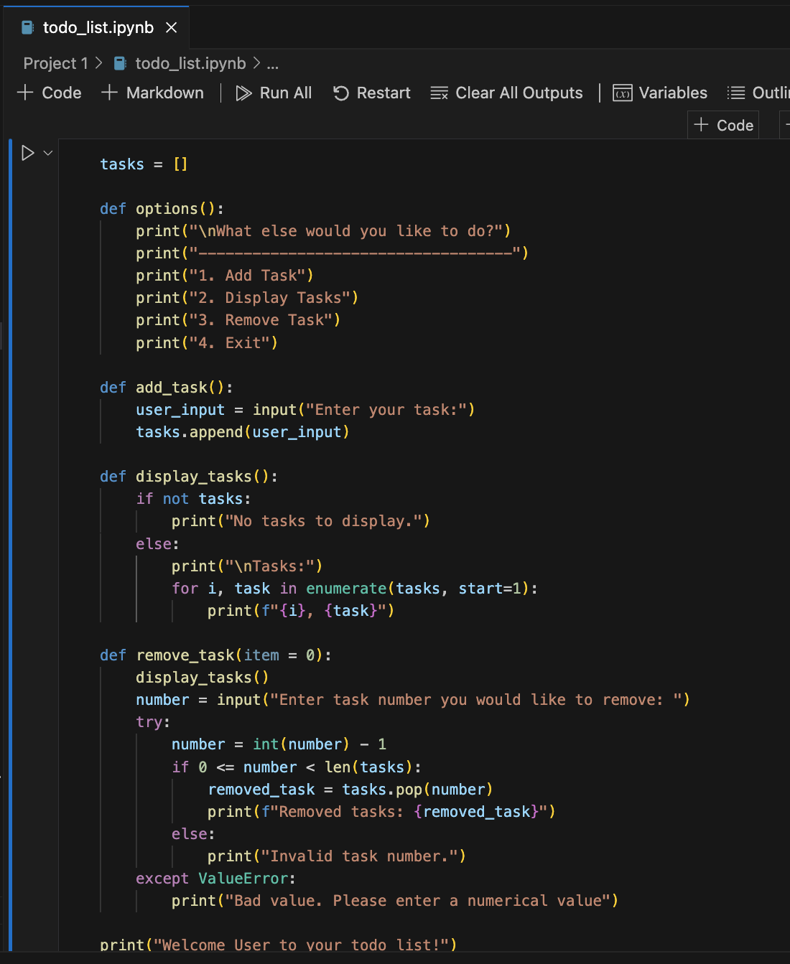

Figure 8.Todo List Code

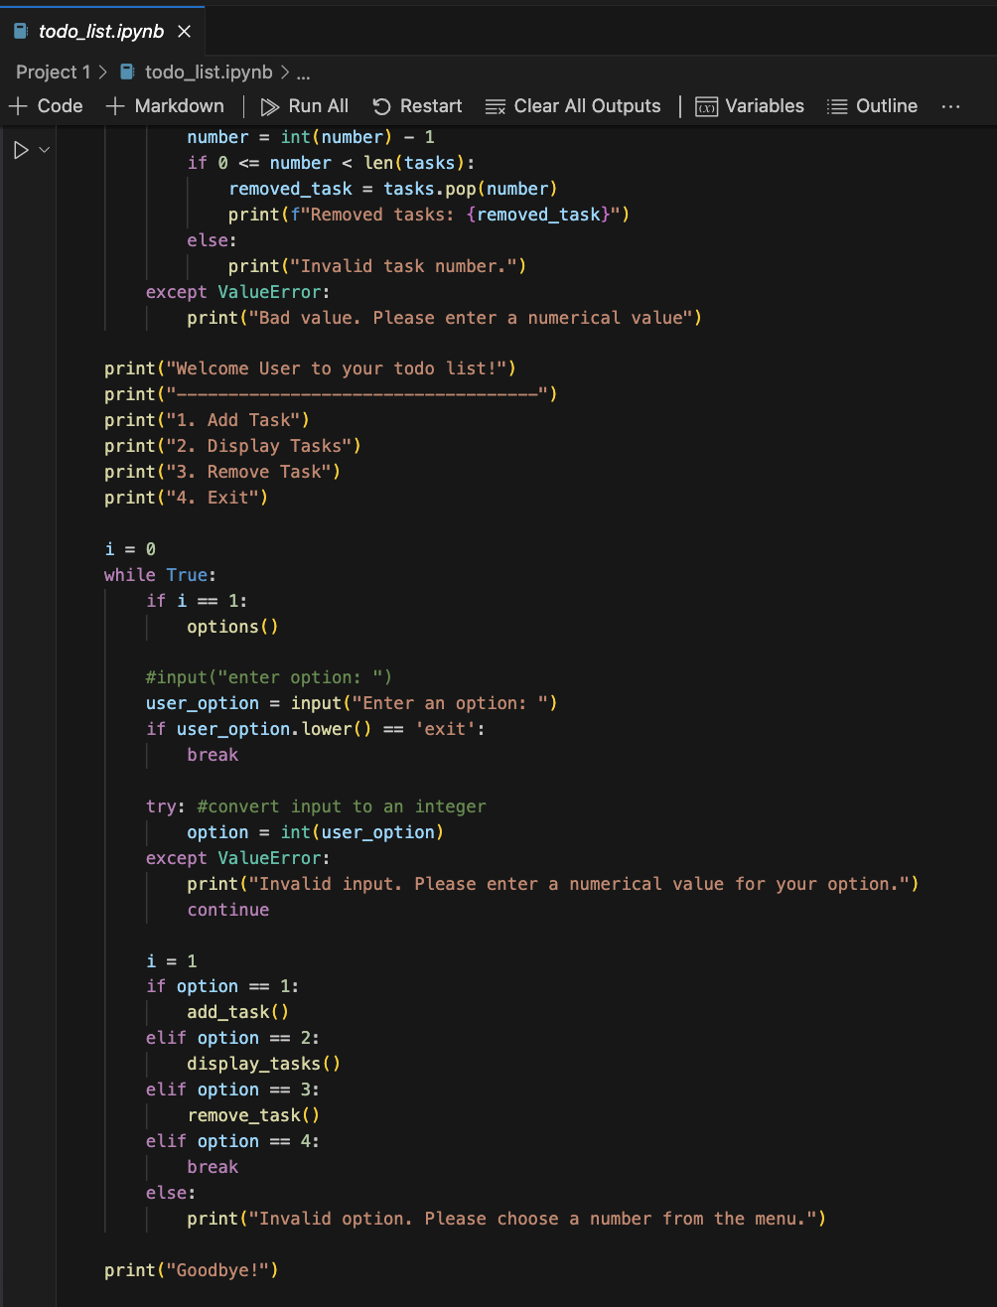Figure 9: Todo List Code (continued)

Similar to the palindrome example, the to-do list application incorporates user input to make it more interactive and useful. Figure 10 displays the code being executed. When the program is executed for the first time, the user is greeted and an options menu is displayed. The user is asked to enter input. Depending on the input entered, a function is ran. Figure 11-13 demonstrate a user adding a task, displaying the tasks, and lastly removing a task before exiting the program.

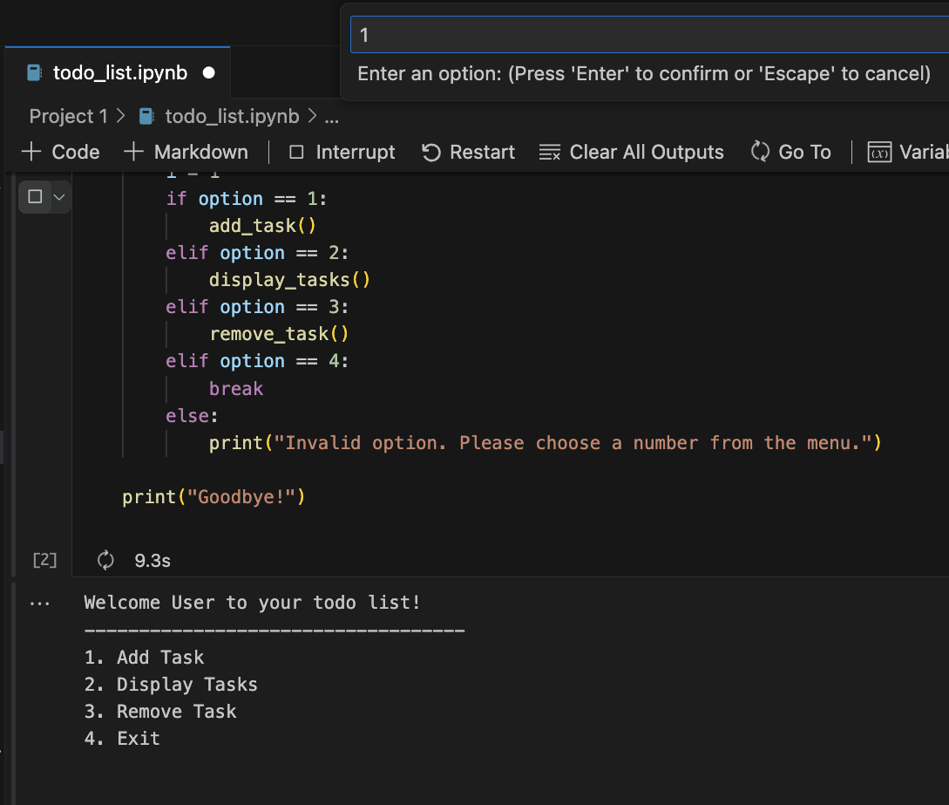*Figure 10.Todo List: Choosing Menu Option*

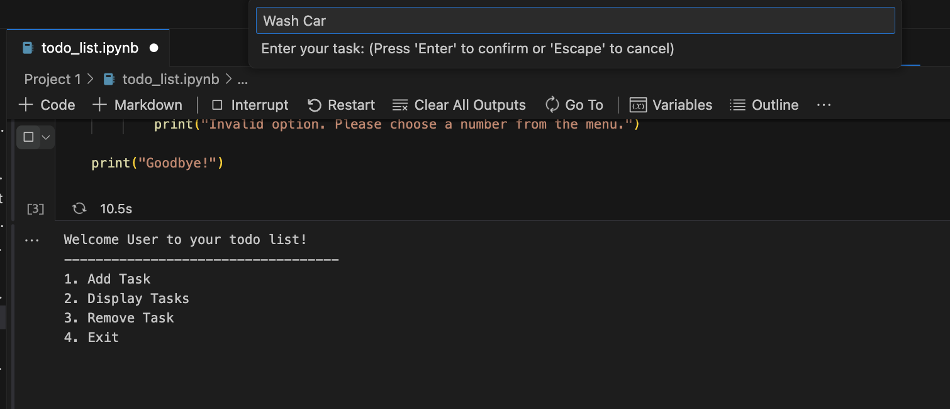Figure 11.Todo List: Adding a Task

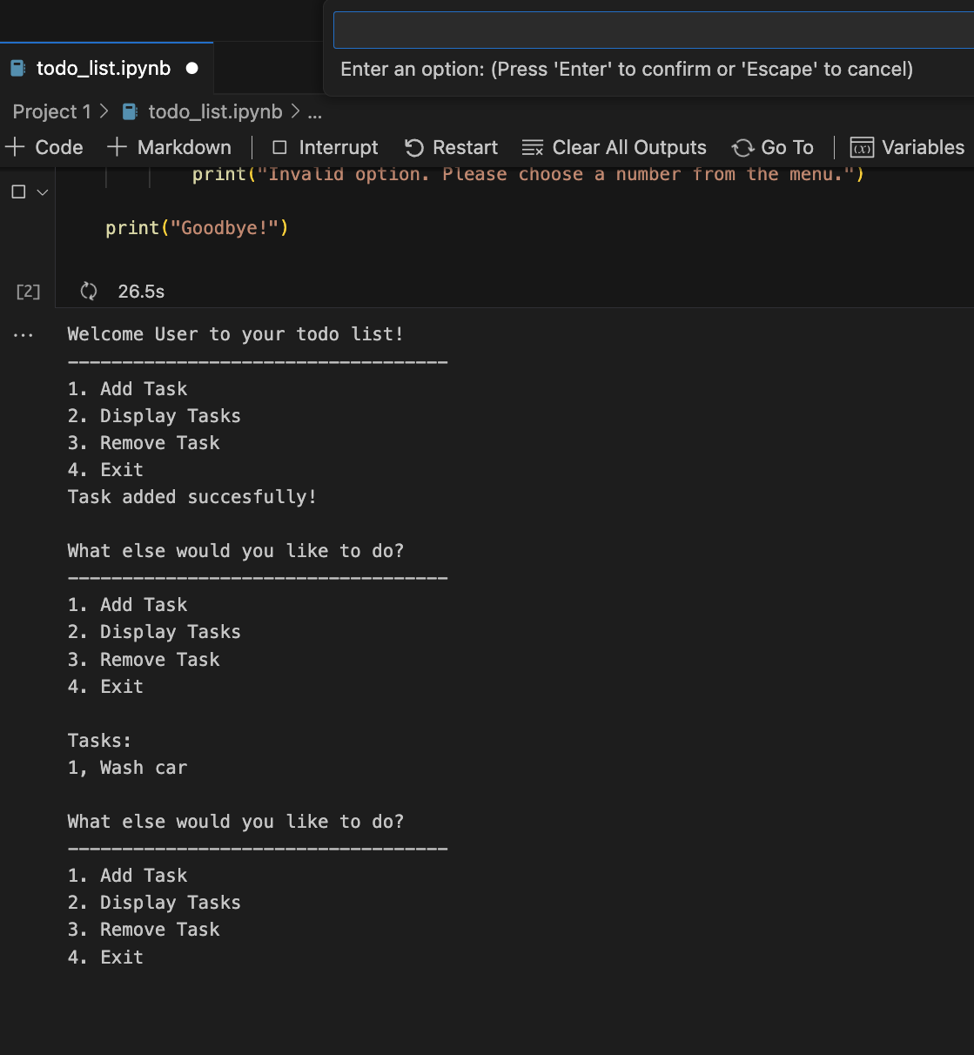Figure 12.Todo List: Displaying Tasks

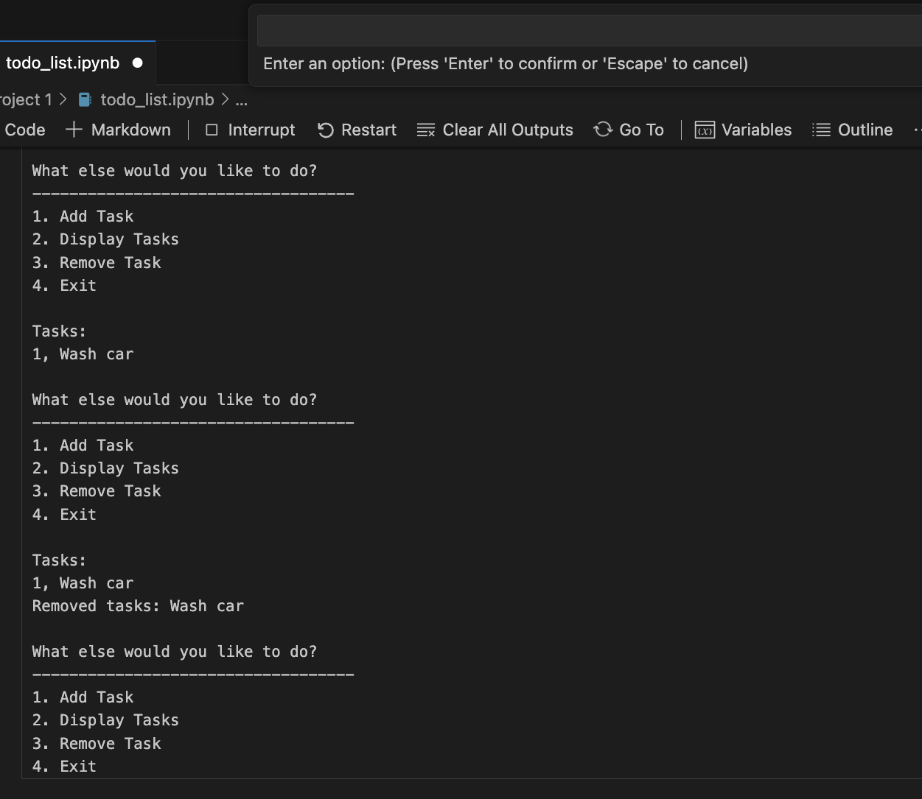

Figure 13.Todo List: Removing a task output

Similar to the palindrome example, one of the problems encountered was properly handling user input so that the program behaved as expected. In a similar fashion, a *`try...except`* block was implemented to handle any input the user entered that did not result in a valid integer. Figure 14 and 15 shows how the program requests input again if invalid input is detected.

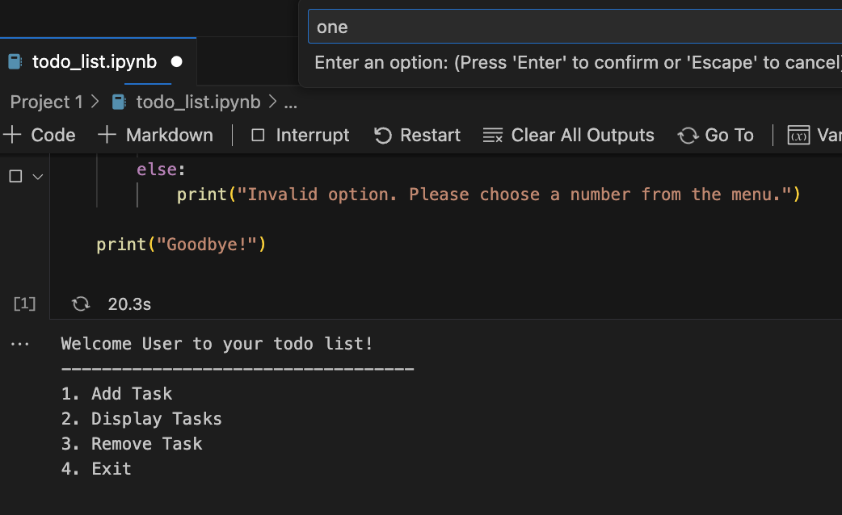*Figure 14.Todo List: Error handling*

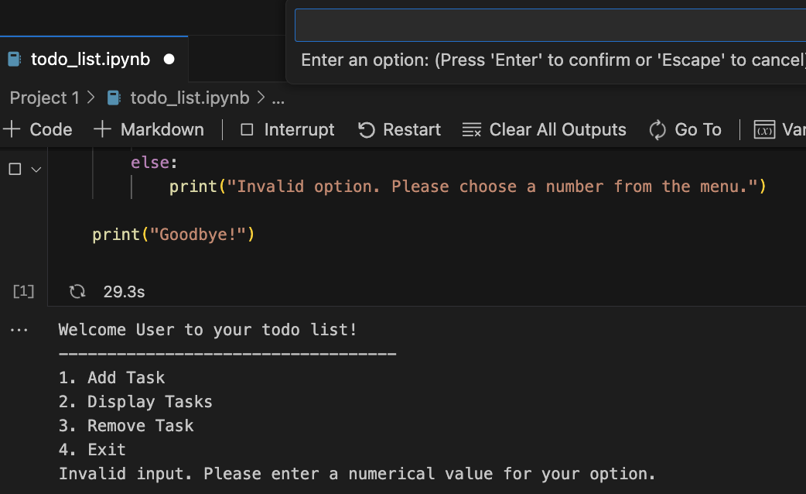*Figure 15.Todo List: Error handling output*

Unlike the palindrome example, an ‘exit’ option was implemented into the program. This option uses an *`if`* statement and the *`lower`* method for string manipulation to determine if the user has typed ‘exit’ to stop the program. Figure 16 and 17 demonstrate this portion of the code being run.

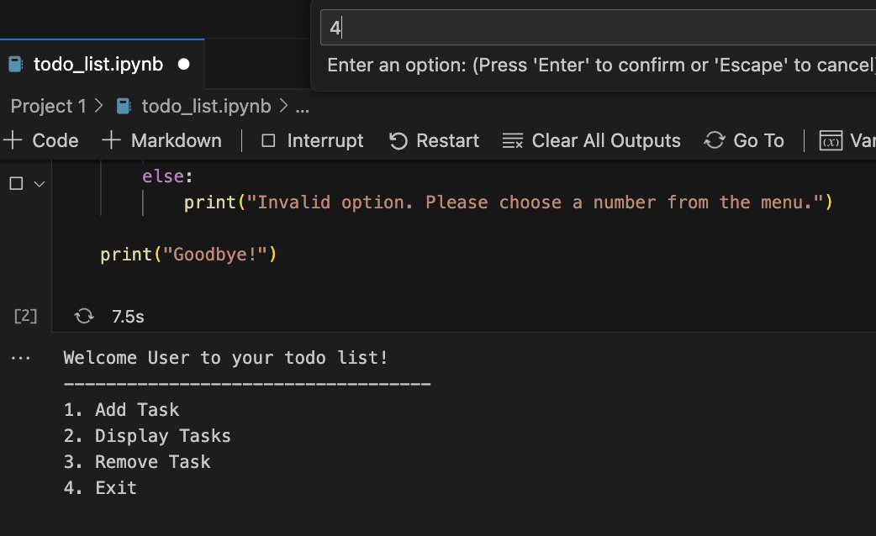*Figure 16.Todo List: Exiting program*

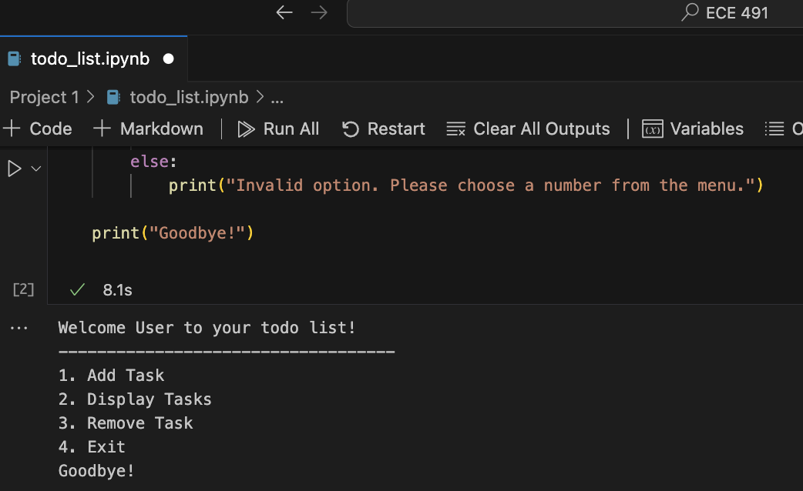Figure 17: Todo List: Exiting program output

Like most programs, this is far from perfect. To improve upon this code a better handling of user input could be implemented to deal with negative numbers being entered to select an option to improve the robustness exception handling. With further review, the initial menu display could be incorporated with the *`options`* function to avoid code duplication. Additionally, the main loop can be simplified and include an exit message directly in the main code logic to improve functionality.

# **4. Guessing Game Code Analysis**

This Python script implements a number guessing game where the user attempts to guess a randomly generated number within a specified range and within a limited number of attempts. Figure 18 and 19 display the final completed code. First, the *`random`* module is imported to gain access to the ability to generate random numbers. A *`while True`* loop is incorporated to continually prompt the user for input until ‘exit’ is chosen to stop the game. Similar to the previous projects, an *`if`* statement along with the *`lower`* method for string manipulation, and a *`try...except`* block is used to validate user input and catch and handle *`ValueError`* issues when converting the user inputs to integers.

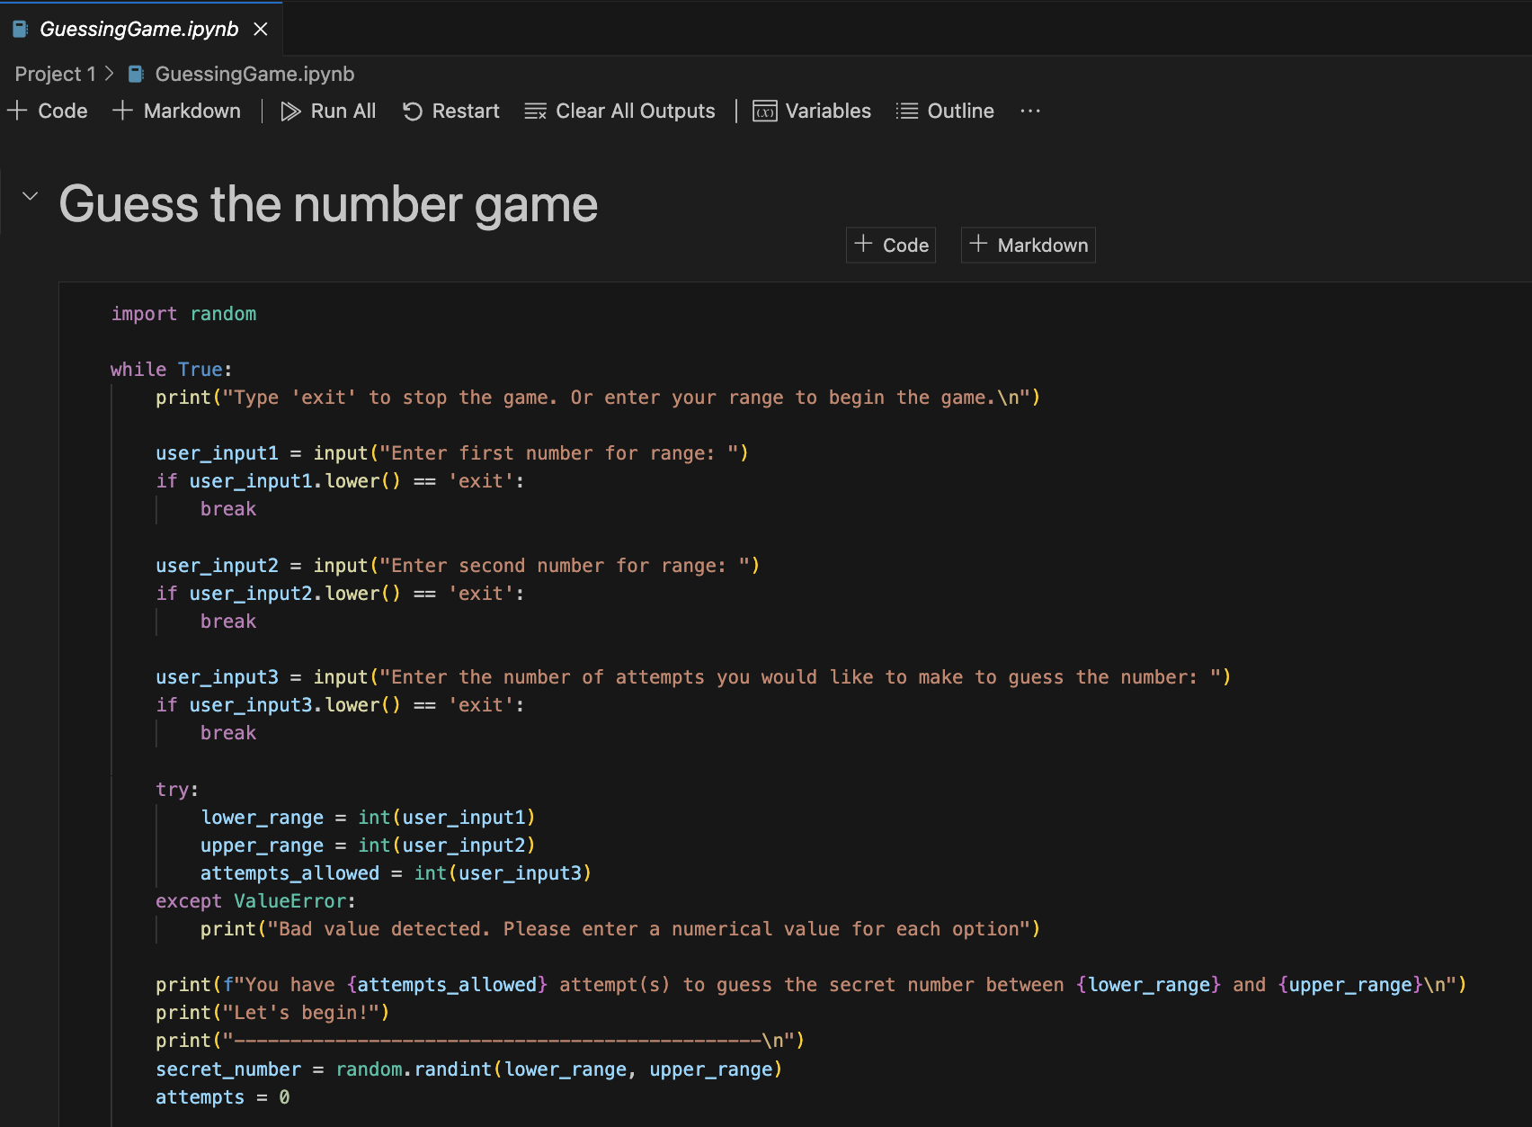*Figure 18.Guessing Game code*

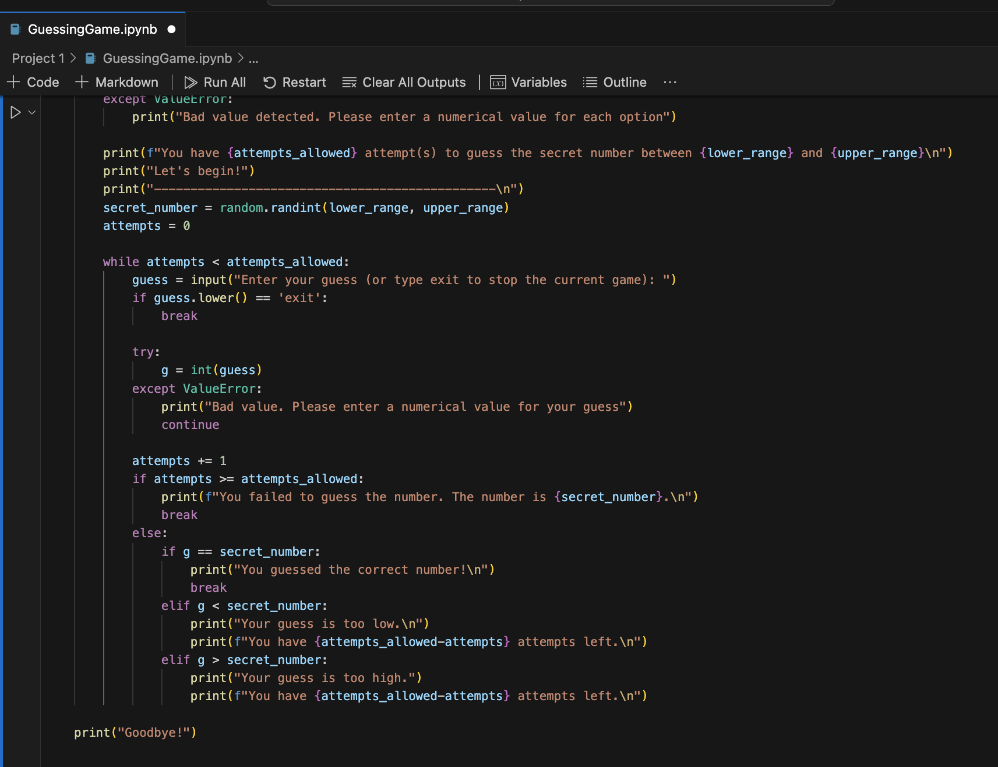*Figure 19.Guessing Game code (continued)*

Another `while True` loop within the first loop handles the guessing attempts. User input is taken to begin the game by having the user define the range to generate a random number and the number of attempts they would like to have to guess the number. See Figures 20-25 for example input and output of a user running the program.

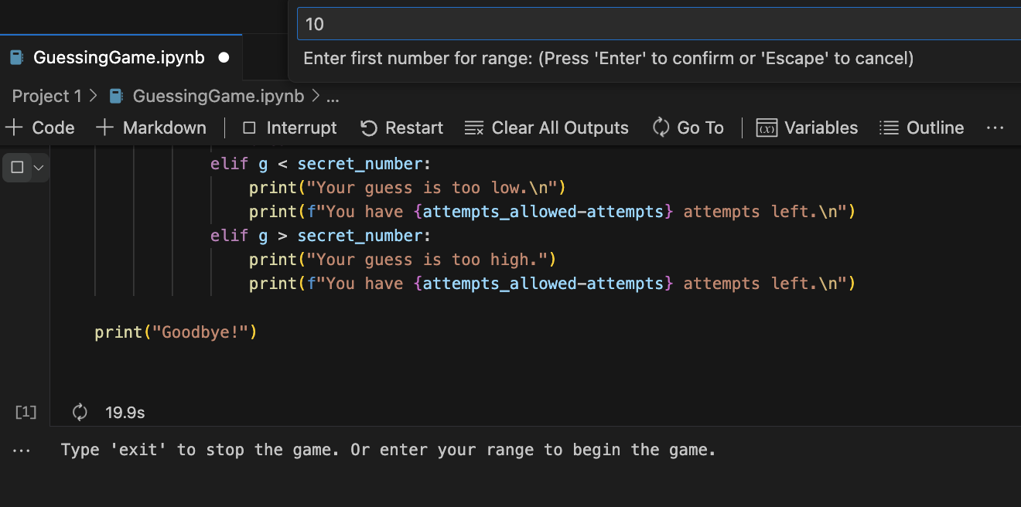*Figure 20.Guessing Game: Example input for entering lower range*

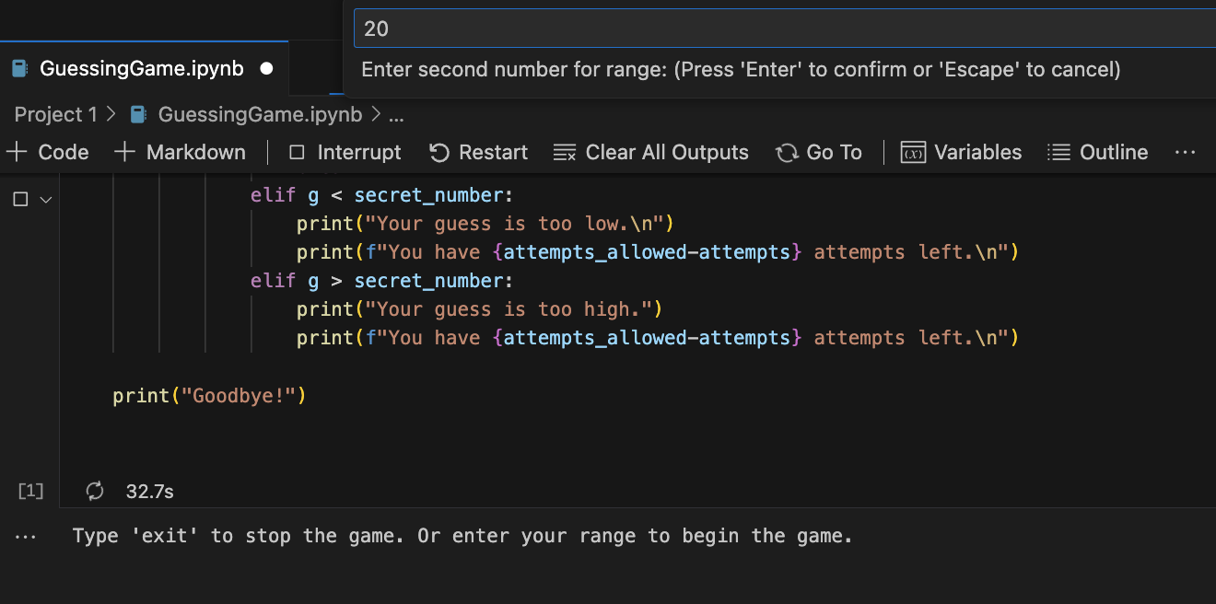*Figure 21.Guessing Game: Example input for entering upper range*

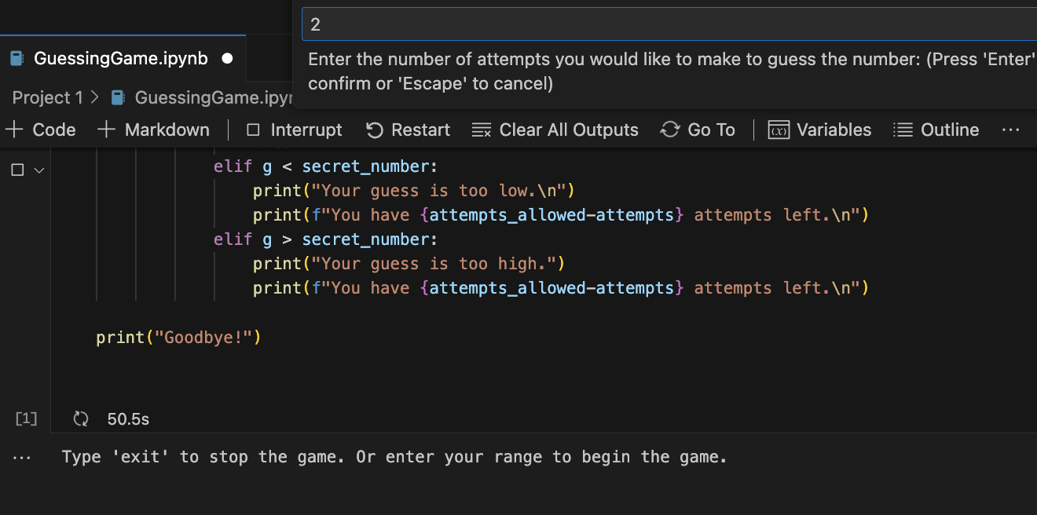*Figure 22.Guessing Game: Example input for entering number of attempts*

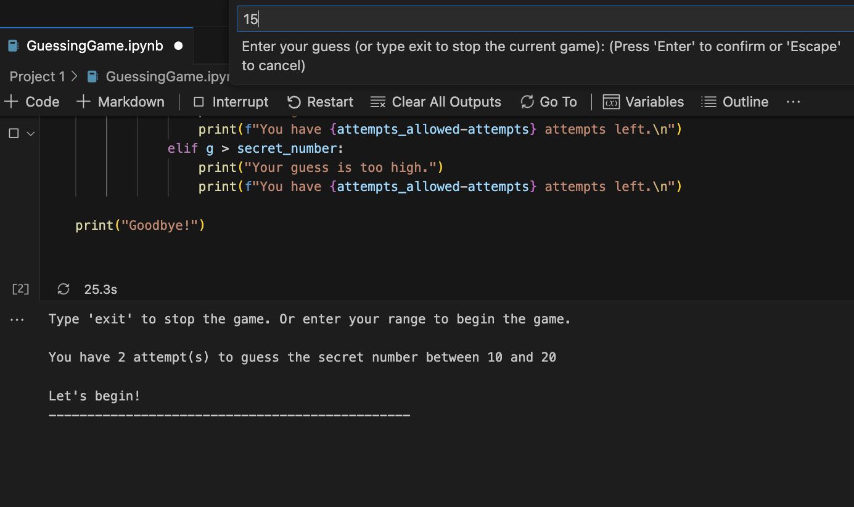*Figure 23.Guessing Game: Example output and input of entering a guess*

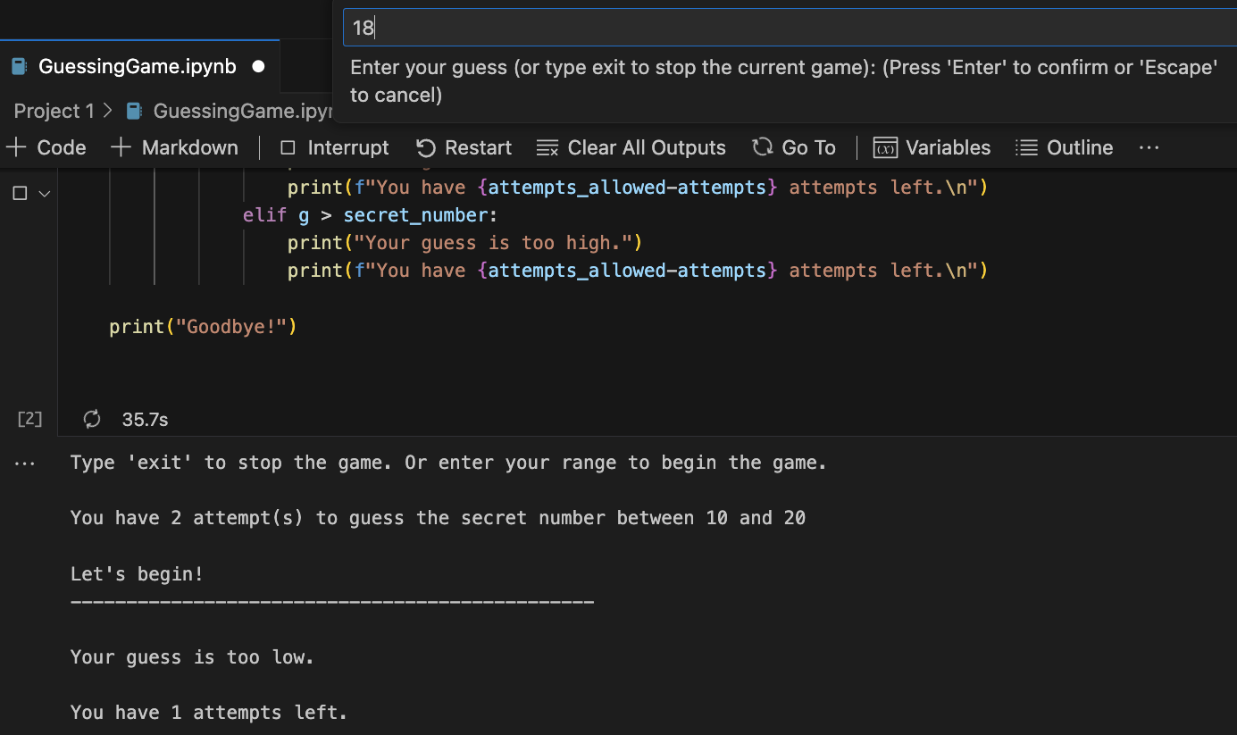*Figure 24.Guessing Game: Example output after a bad guess*

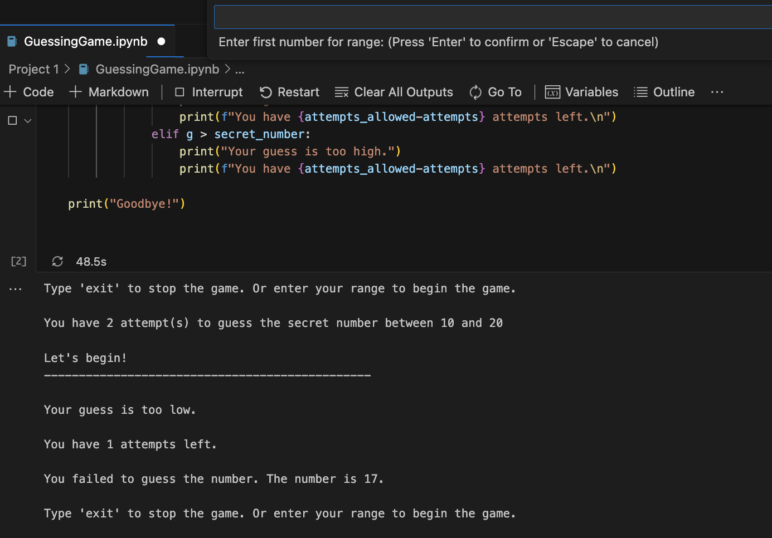*Figure 25.Guessing Game: Example output after losing*

Conditional statements are used to handle various scenarios, from exiting the game to quit, checking the guessed number, and comparing the guess to the secret number to print out various messages to the user for hints. Formatted strings are used within the conditional statements to provide feedback to the user such as the number of attempts left and whether or not the guess entered is above or below the secret number. Figures 24 demonstrate this capability alerting the user that their guess is too low.

To increase readability and efficiency, a function could be created to handle getting valid input from the user. This could be accomplished by incorporating a *`while True`* loop along with using conditional statements. Additionally, a *`try...except`* block would be used to handle errors. This change alone would shorten the length of the code and improve its readability.

# 5. Gain Calculator and File Storage Code Analysis

For the last project example, I based it on a real world application. Currently, on a particular project I am working on, I have to use an oscilloscope to collect the input peak-to-peak voltage of a waveform applied to a pin on a circuit board, and then collect the output peak-to-peak voltage of a waveform from a different pin. With these values, I must then calculate the gain in decibels and store the collected values for later use, modification, and reporting. For this particular example, I decided to demonstrate file modification and handling in Python. Figure 26 shows the completed code.

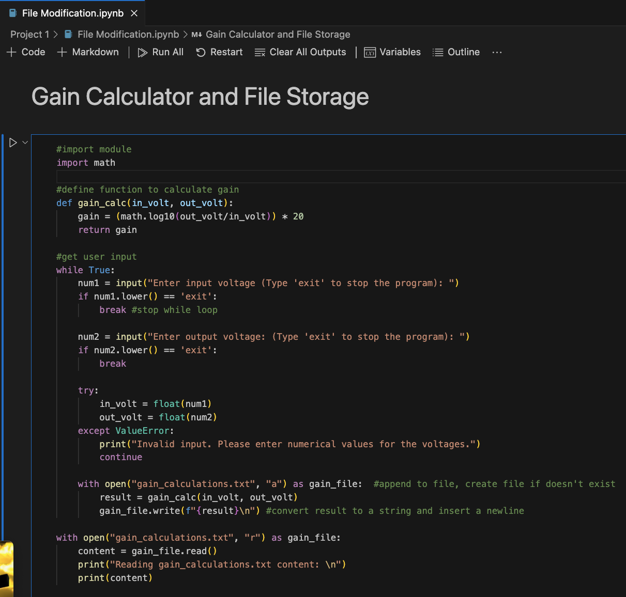*Figure 26.Gain Calculator code*

Firstly, I import the *`math`* module into the code to gain access to logarithmic functions. I then create a function called *`gain_calc`* to calculate the gain value using two parameters, the input voltage and the output voltage, and return the calculated value. Since my real-world application uses connections to an oscilloscope and other complex functionalities, I use a `while True` loop to prompt the user to enter the input voltage and the output voltage. Similar to my previous examples, conditionals are used to handle if the user would like to stop the program. Additionally, a `try...except` block is used to catch and handle *`ValueError`* issues when converting the user input strings to floating integers. If the values are correctly converted to floating points, a text file is opened (or created if it doesn’t exist) and the result of the gain calculation is produced, then converted to a string using *`f`* statements, and then written to the text file. Figures 27-30 demonstrate these functionalities.

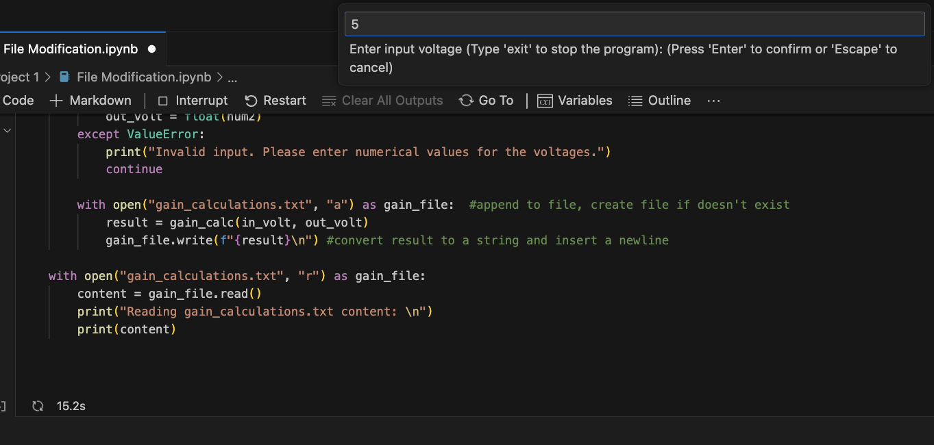*Figure 27.Gain Calculator: Example prompting for input voltage*

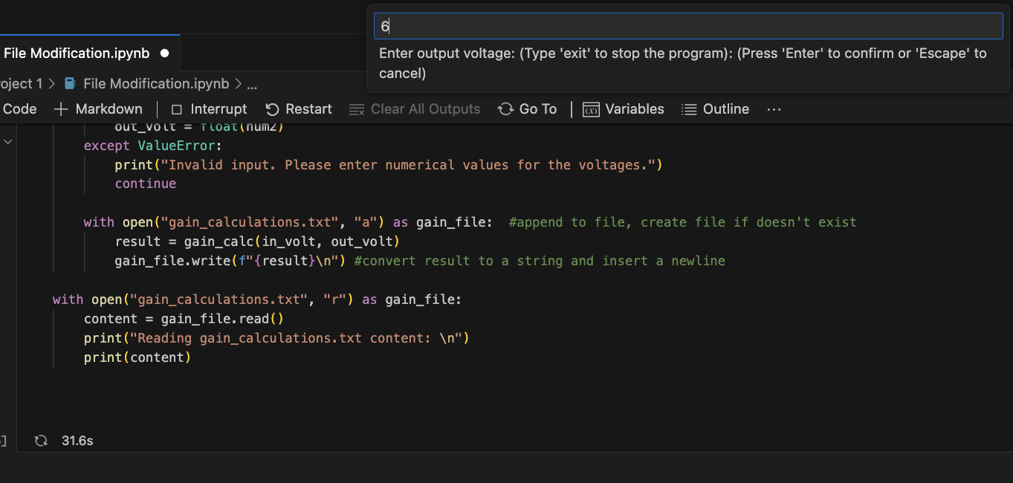*Figure 28.Gain Calculator: Example prompting for output voltage*

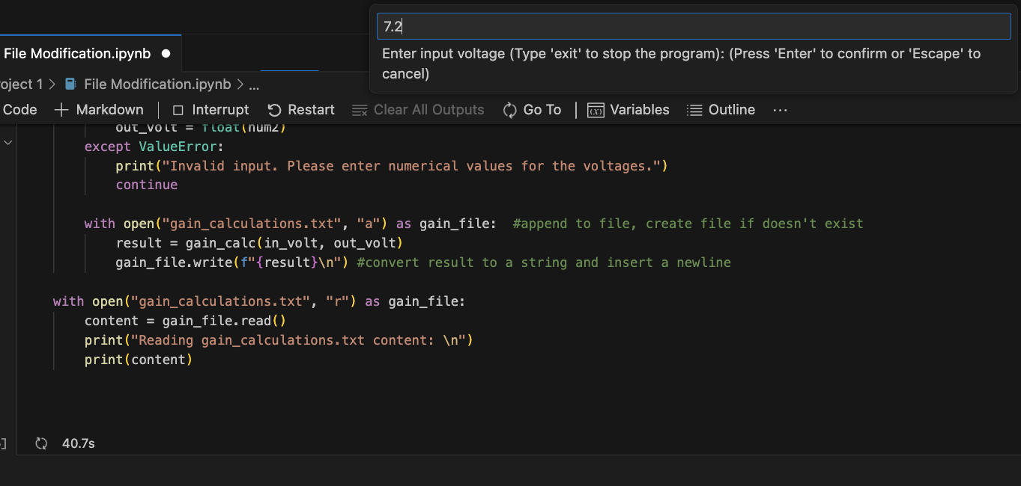*Figure 29.Gain Calculator: Example showing repeated prompt for input voltage*

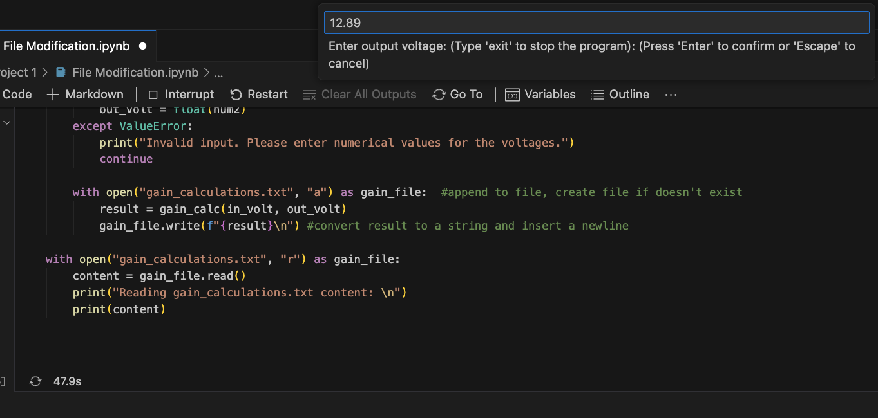*Figure 30.Gain Calculator: Example showing repeated prompt for output voltage*

To mimic my real-world application, the user is prompted to enter the next input and output voltage values until they are done. Once the user types ‘exit’, the text file is read and the content of the file is printed to the screen. See Figures 31 and 32 for demonstration.

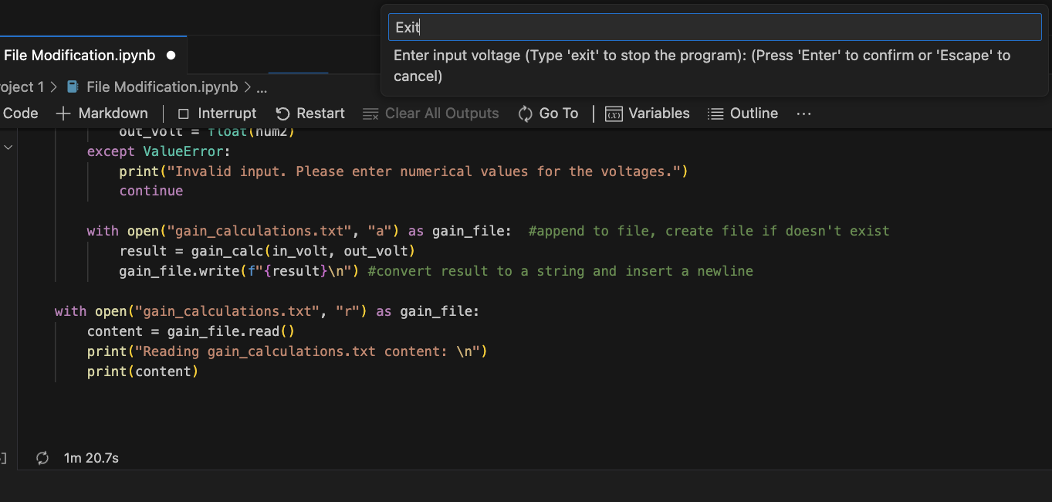*Figure 31.Gain Calculator: Exiting program*

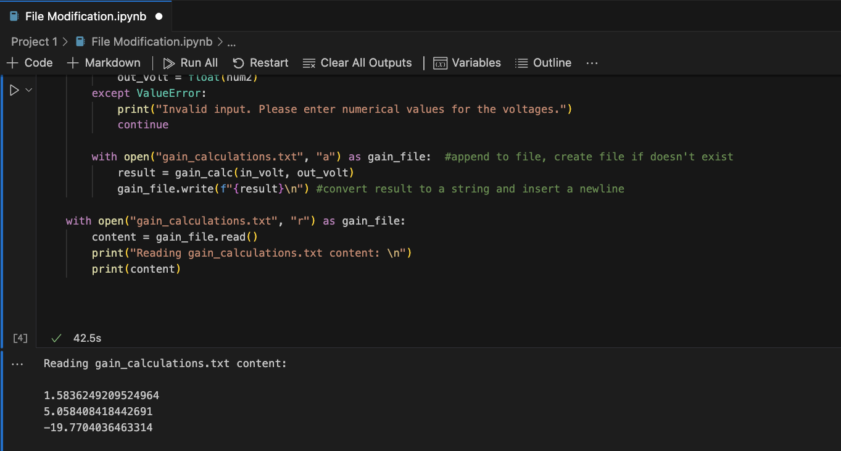*Figure 32.Gain Calculator: Output*

The following sections include screenshots and explanations/comments of quick examples I created while reading *"A Whirlwind Tour of Python"* (VanderPlas, 2016), from conversations I had with my classmates, and examples I encountered through research to better understand the reading. Many of the coding examples are short and to the point, serving mainly as a basis of class notes to demonstrate to myself an understanding of how Python works.

# 6. Python Semantics: Variables

The Python script shown in Figure 33 is an exercise demonstrating how to define and use variables. It is a simple conversion calculator. It assigns integer values to three variables as conversion factors. It then asks for input from the user and converts the string to a float. The types of each variable inputed by the user is printed to the screen. An *`if`* statement is used to determine if all three variables are integers, and if the result is true, the values are converted by multiplying the inputted values by the correct conversion factor. Lastly, the inputted values and converted values are printed out to the screen for the user to see.

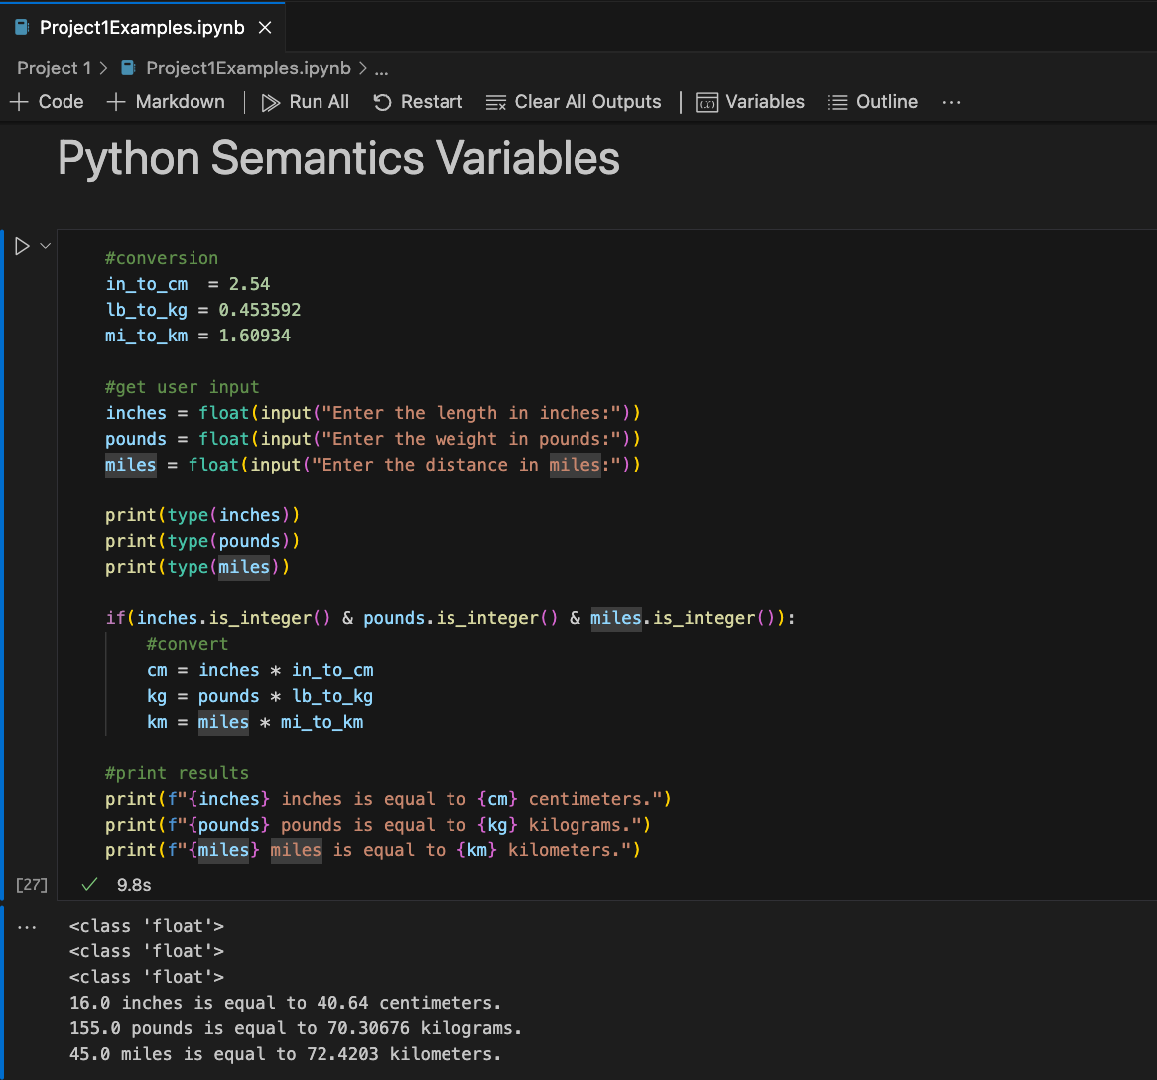*Figure 33.Python Semantics Variables: Conversion calculator code and output*

# 7. Python Semantics: Operators

Figure 34 shows a code snippet of a simple calculator that performs a few different operations based on user input. It uses membership identity to determine if the user’s input is in a defined list of choices. If the user’s choice matches a string in the list, then the user is prompted to enter the first number for the operation and then a second number. The user’s chosen operation is then performed on the two numbers and then printed to the screen along with the two numbers the user inputted and the operation choice. Figure 35 shows example output after the code has been executed.

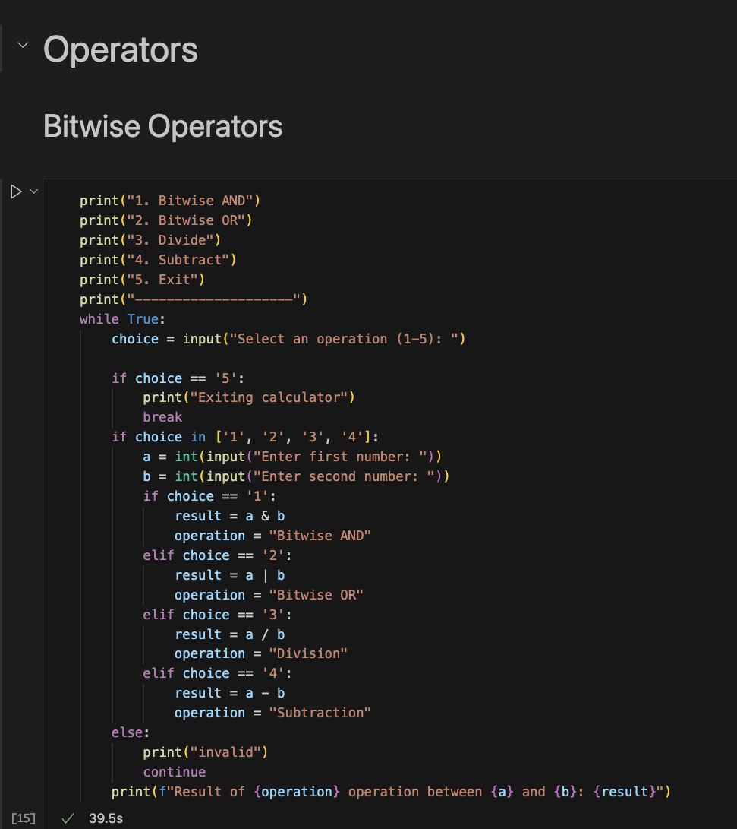*Figure 34.Python Semantics Operators: Simple calculator code*

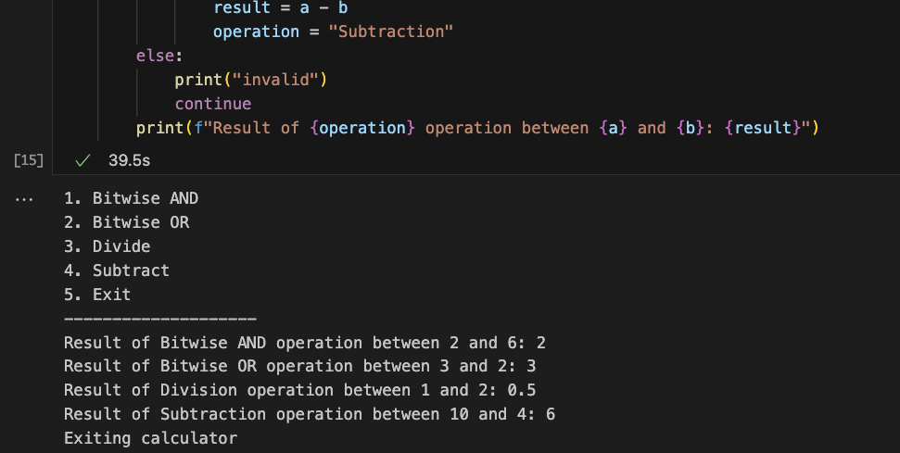*Figure 35.Python Semantics Operators: Simple calculator output*

# 8. Built-In Scalar Types

Figure 36 shows another simple calculator exercise. This calculator uses *`float`* to handle both integer and floating-point numbers. The user inputs responses as strings. The first two responses are converted to floats and stored in the variables *`num1`* and *`num2`* for calculations. The third input is for choosing an operation and is stored as a string in *`operation`*. Conditional statements are used to determine how to calculate the result based on the *`operation`* variable.

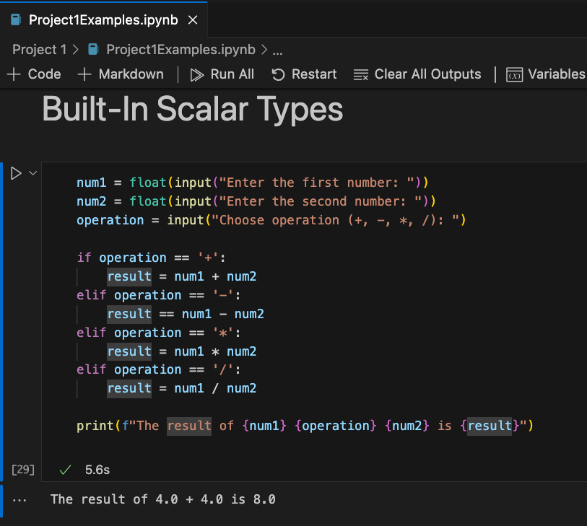*Figure 36.Built-In Scalar Types: Simple calculator code and output*

# 9. Built-In Data Structures

This exercise demonstrates the built-in data structures in Python. It is a simple Python script that creates and manipulates a dictionary containing a list of my favorite movie titles as the key and their respective release years as the values. Figure 37 shows the completed code. The code demonstrates how to access a value from the dictionary by using the dictionary keys. The code includes other functionality of manipulating a dictionary by demonstrating how to update a value using a specific key; adding a new entry with its release year; and even deleting an entry along with its release year from the entire dictionary by using the *`del`* statement. A *`for`* loop is incorporated to show how to iterate over all the key-value pairs in the dictionary using a *`for`* loop and the *`items`* method. Figure 38 provides the output of this code.

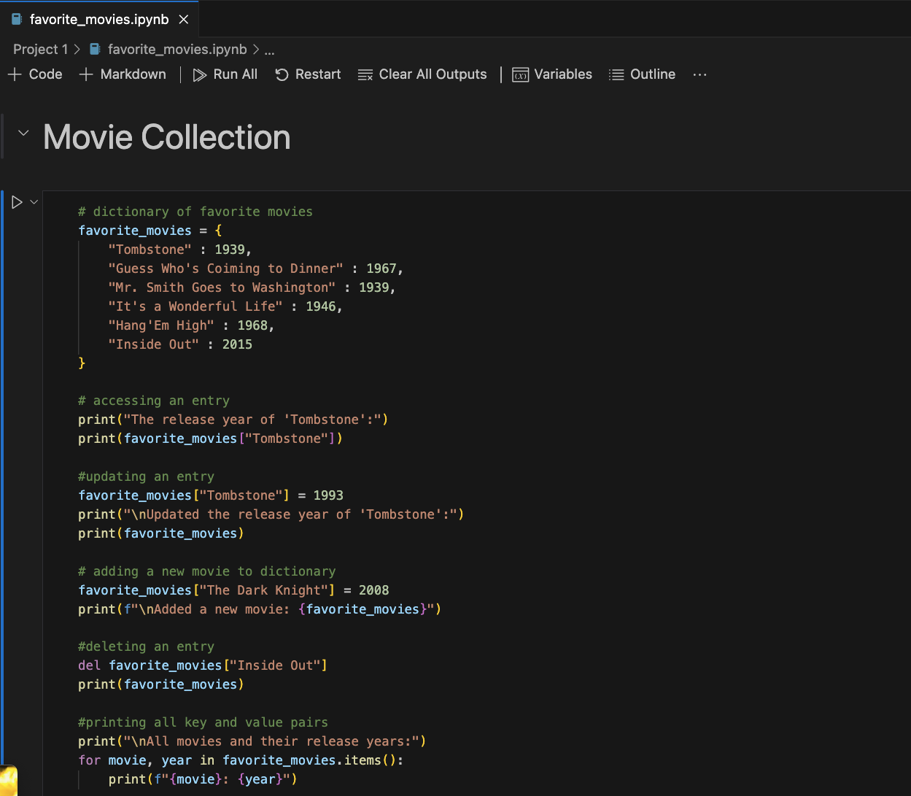*Figure 37.Built-In Data Structures: Movie collection code*

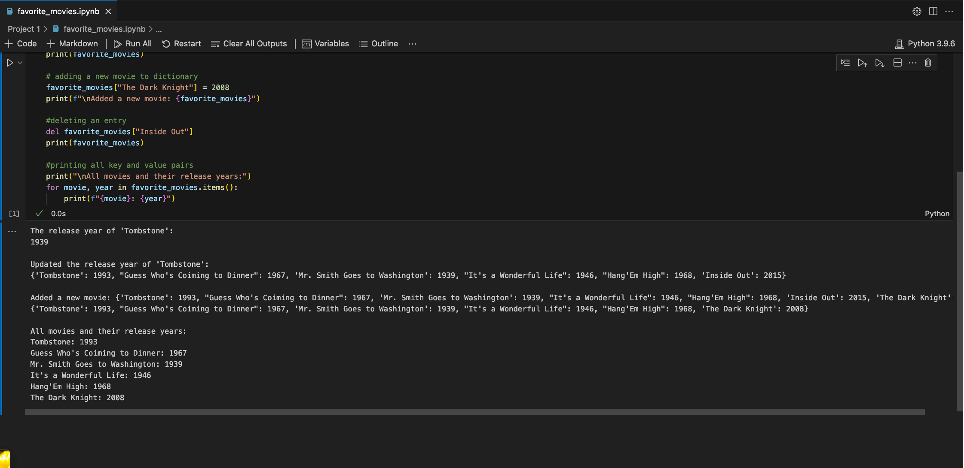*Figure 38.Built-In Data Structures: Movie collection output*

# 10. Control Flow Statements

Figure 39 shows a simple exercise to demonstrate control flow. In the first example, a *`for`* loop is used to iterate through a list of names. The names are printed to the screen twice. A `while True` loop is incorporated to run this loop iteration repeatedly until the condition of `i > 7` is met. In the second example, a defined list of numbers from 1-10 is iterated over using a *`for`* loop. For each number that meets the condition of being even, that number is printed to the screen.

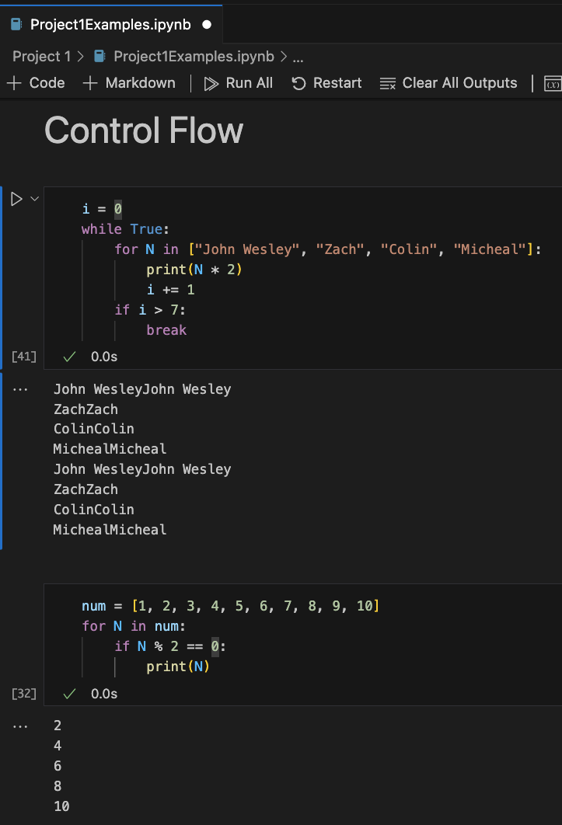Figure 39: Control Flow Statements code and output

# 11. Defining Functions

The following example in Figure 40 is a very simple demonstration to show how to define functions in Python. A function to divide two numbers was defined. This function takes in two integers, *`a`* and *`b`*. The program asks the user for the numerator and the denominator. These values are converted to floating-point integers using the *`float`* function. The resulting values are then stored in the variables *`num`* and *`den`*. The *`divide`* function is called and prints the result to the screen.

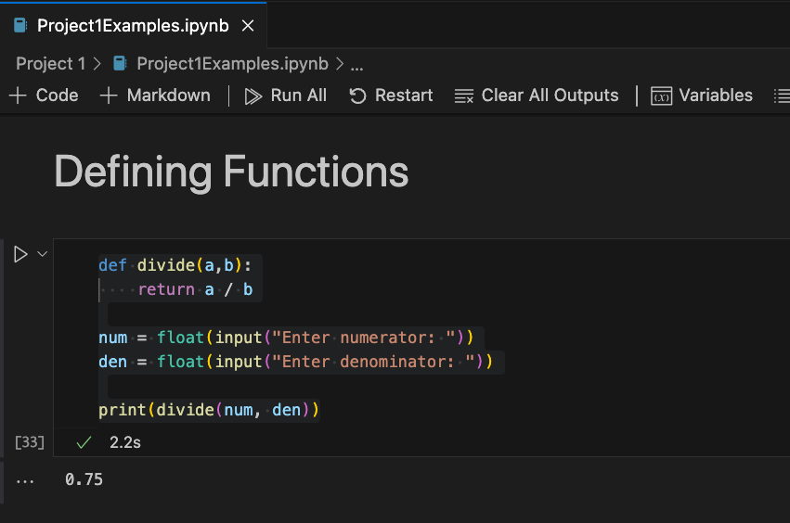*Figure 40.Defining Functions Code and Output*

# 12. Errors and Exceptions

Using the previous example from the Defining Functions sections, the code was updated to improve its functionality by incorporating a `try...except` block. An exception was added to the *`divide`* function to handle *`ZeroDivisionError`* if the user inputs a zero as the denominator. Additionally, an exception was added to catch *`ValueError`* issues if the user entered non-numerical values that could not be converted to floating-point integers by the *`float`* function. Figure 41 shows the updated code along with example output if the user entered 0 for the denominator.

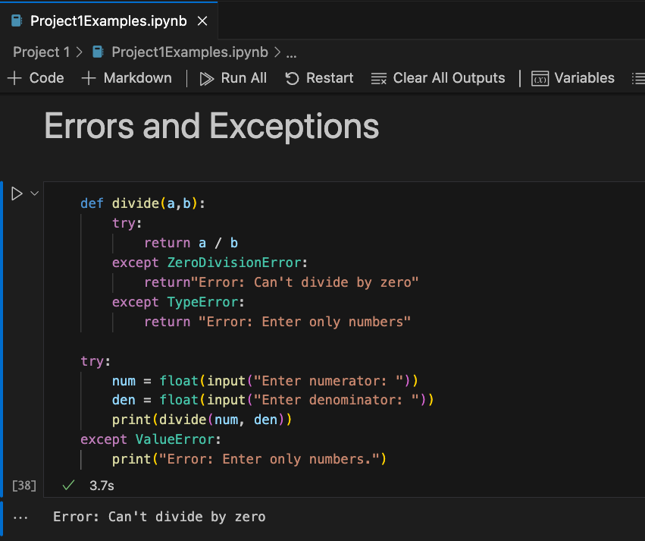*Figure 41.Errors and Exceptions code and output*

# **13.** **Iterators**

Iterators provide a way of repeating a similar calculation. My above mini-projects demonstrate using iterators to perform a calculation a set number of times or simply iterate over a list and display the values. Figure 42 shows my example of using the built-in *`iter`* function to check if something has an iterator interface. Figure 43 \provides an example of iterating through a list and displaying the index of each element in the list.

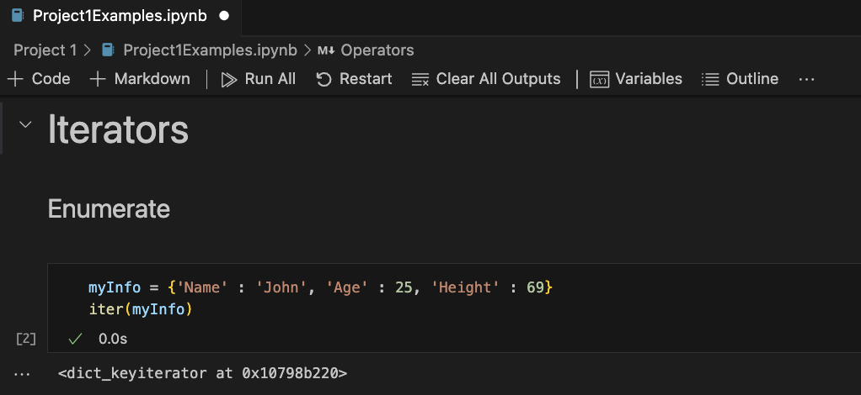*Figure 42.Demonstrating `iter` function*

Figure 43 demonstrates a second way to iterate over values in an array and track the index by using the *`enumerate`* function. This is applied to the same list of years named *`myList`* to demonstrate similar functionality.

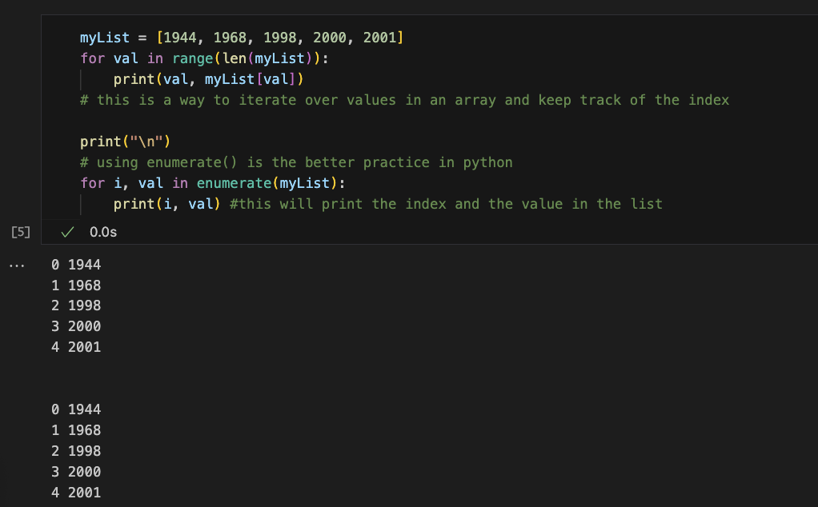*Figure 43.Demonstrating iteration and enumeration code and output*

Figure 44 shows an example of using the *`zip`* iterator. Two lists were created, a characters list with fictional characters as the elements, and an abilities list which correspond to each characters unique abilities. Using the *`zip`* iterator, each element from *`characters`* list is paired with an element from the *`abilities`* list creating tuples of (character, ability). The *`for`* loop iterates over the tuples and uses the *`print`* function to output a formatted string describing each character’s abilities.

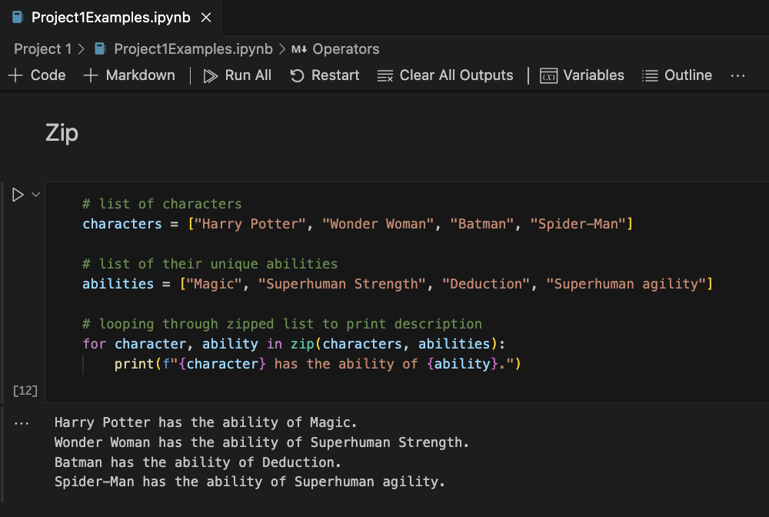*Figure 44.Demonstrating `zip` code and output*

Figure 45 shows an example of using the *`map`* iterator. The function *`toPigLatin`* is defined taking a single word as an argument and checking if the first letter of the word is a vowel. If the first letter is a vowel, it appends the suffix “way” to the end of the word. Otherwise, it moves the consonant of the word to the end of the word and appends the suffix “ay” to the end of the word. A list of words is defined to be converted to Pig Latin. The *`map`* function applies the *`toPigLatin`* function to each word in the *`wordlist`* as the *`for`* loop iterates over the result of *`map`*. The resultant word is then printed to the screen followed by a space instead of a newline.

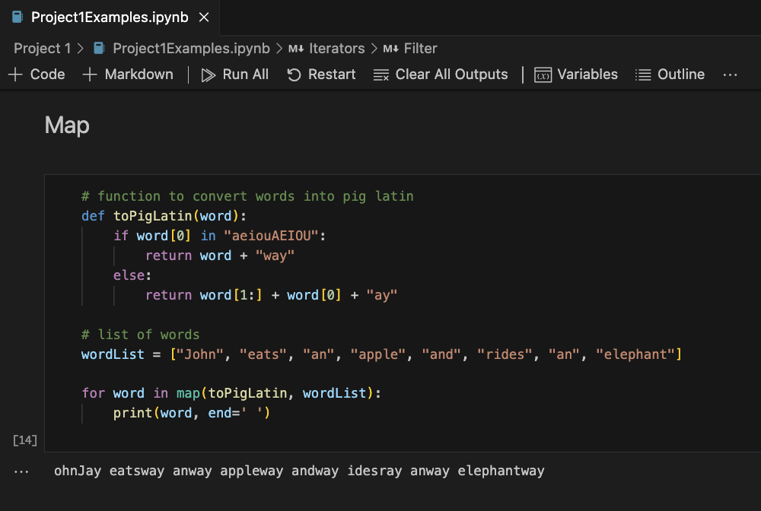*Figure 45.Demonstrating `map` code and output*

Figure 46 shows an example of the *`filter`* iterator. A list of words is defined. A lambda function is defined that takes a single argument and returns *`True`* if the letter ‘e’ is in the word, and returns *`False`* if the word does not contain the letter ‘e’. The return value is assigned to the variable *`contains_e`*. A heading to display is printed, and then the *`filter`* function is used to apply the *`contains_e`* lambda function to each word in the *`words`* list. This creates an iterator that produces only the words from the list that contains the letter ‘e’. The *`for`* loop iterates over this filtered list and prints each word to the screen.

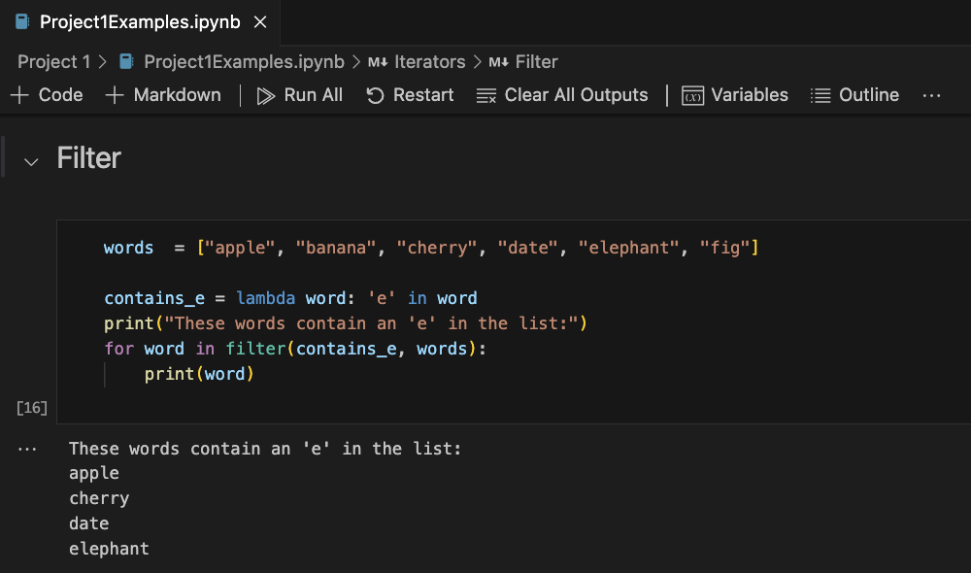*Figure 46.Demonstrating `filter` code and output*

# 14. List Comprehensions

List comprehension provides a concise way to construct lists. Figure 47 shows a basic example of creating a list. Numbers are generated in a sequence by *`range(20)`* and are iterated over by the variable *`x`*. The value from *`range`* is taken and cubed. The resultants are collected in a new list.

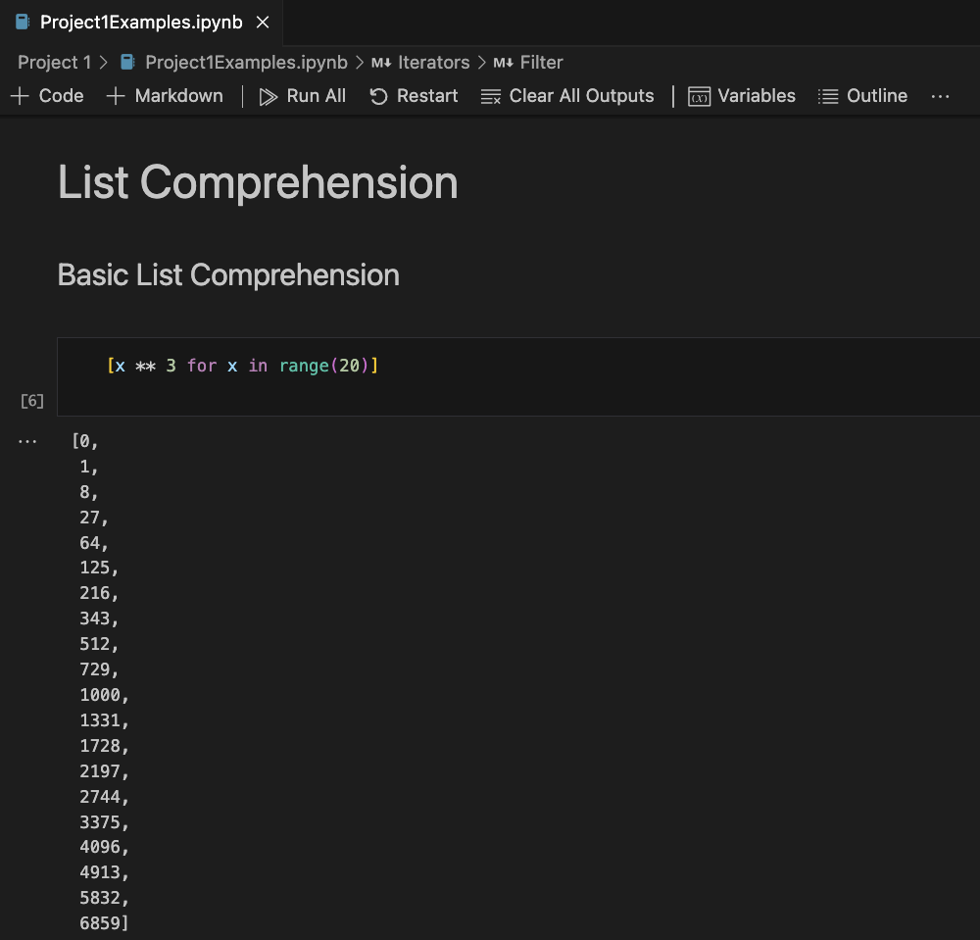*Figure 47.Basic list comprehension code and output*

Figure 48 shows an example of nested list comprehension that generates all possible pairs as tuples. To demonstrate nested list comprehension, two lists, *`colors`* and *`fruits`* were defined. The outer loop (*`for color in colors`*) iterates over each color in the *`colors`* list. While the inner loop (*`for fruit in fruits`*) iterates over each fruit in the *`fruits`* list for every color. For each combination of *`color`* and *`fruit`* a tuple (color, fruit) is created as a new element in the list.

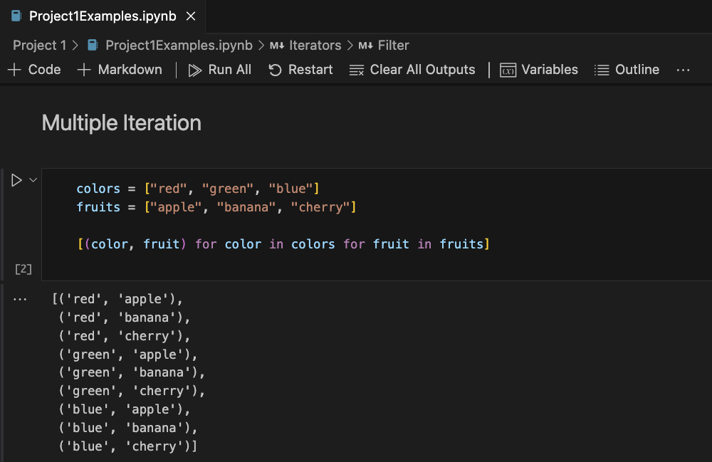*Figure 48.Nested list comprehension code and output*

Figure 49 shows an addition to the code in Figure 47 to demonstrate how conditionals can be added to the list comprehension to create a more complex structure. In the previous example, every number was cubed in the sequence of numbers generated by *`range(20)`*. With the updated code, this list will only produce cubed values if the sequence of numbers generated by *`range(20)`* is divisible by 3.

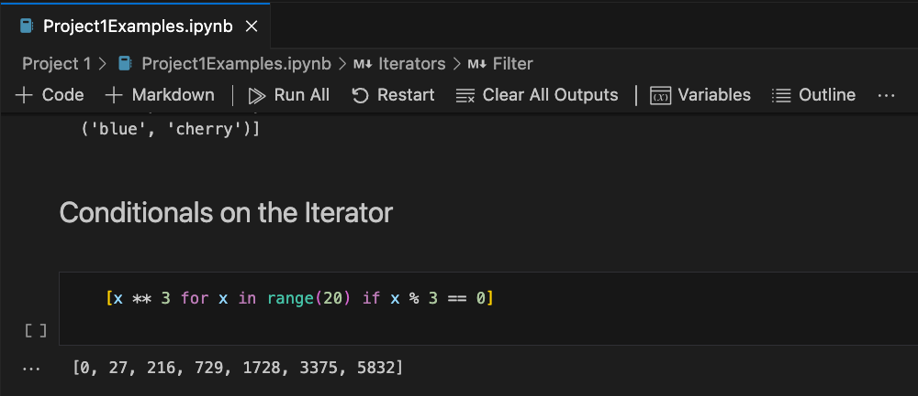*Figure 49.List comprehension structure with conditionals code and output*

Lastly, Figure 50 shows an example of taking list comprehension and applying it for dict comprehension. Here the keys are the numbers generated by *`range(20)`*. if they are divisible by 3, the values of the dictionary are the cubed results.

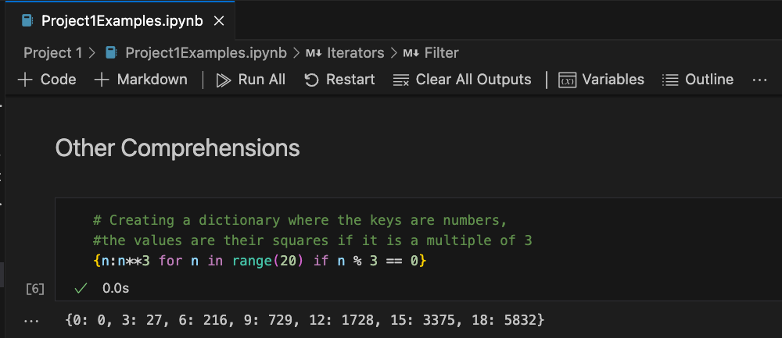*Figure 50.Dictionary comprehension code and output*

# 15. Generators and Generator Expressions

Figure 51 shows code demonstrating how generators are created. Since generators are single use, the example also demonstrates how a generator expression can be called and stopped and then called again, picking up where it left off. In order to use generator expressions repeatedly, a generator function can be used instead which will call a fresh copy of the generator. Figure 52 demonstrates an early example I created of my palindrome project that demonstrates how the generator function can be used to produce an infinite sequence of numbers. The function `is_palindrome(num)` checks if a provided number is a palindrome by using string manipulation to convert the number to a string and slicing the result to reverse it. The sliced string is compared to the normal string to determine if it is the same backwards and forwards. The `palindrome_num_gen(N=10)` function uses the *`yield`* statement to create a generator function to produce an infinite sequence of palindromic numbers.

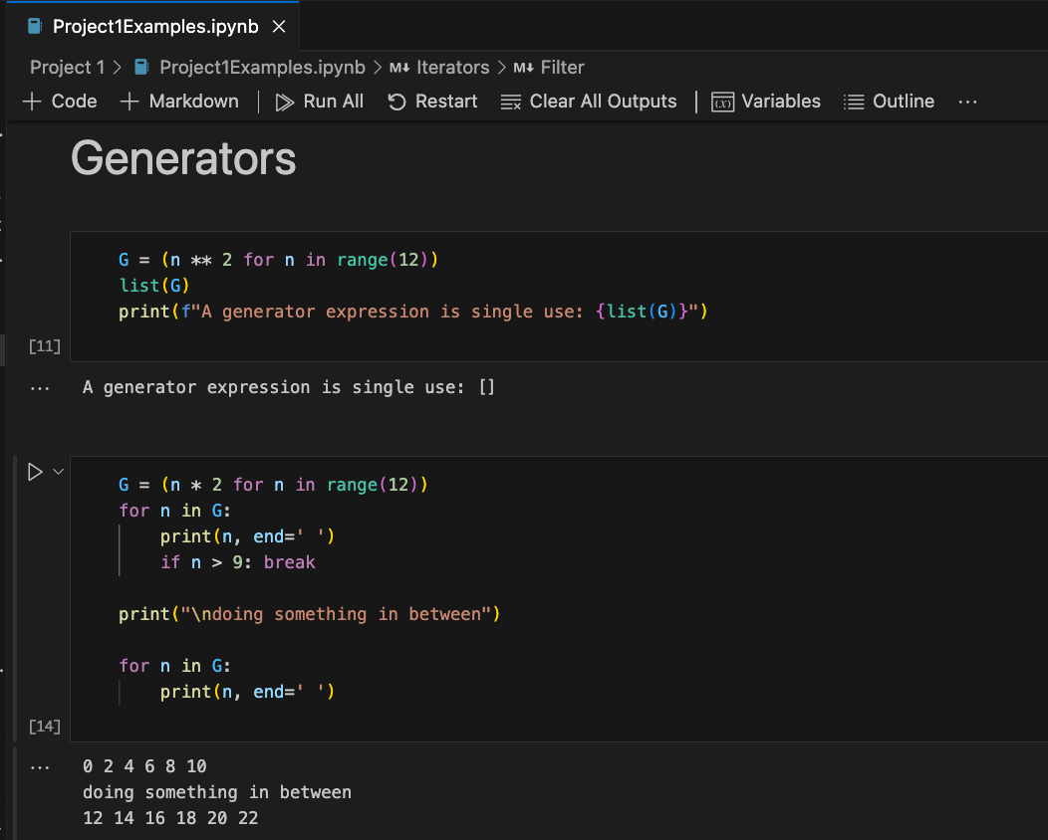*Figure 51.Generator expressions code and output*

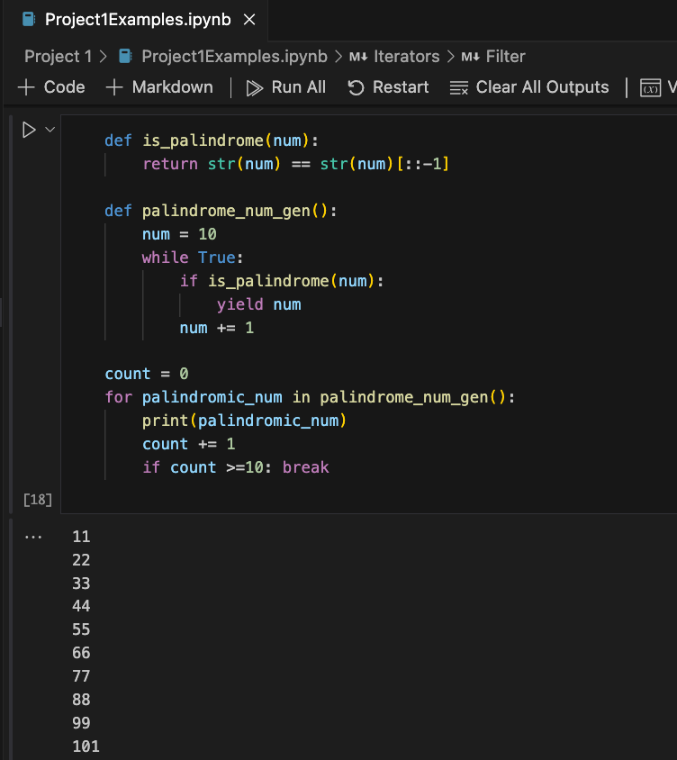*Figure 52.Generator function code and output*

# 16. Modules and Packages

Previous sections have already demonstrated the concept of importing modules into the code, and the section following will use import regular expressions for use. For this section, a simple package creation example was used for the exercise that allows the user to import three functions that can manipulate strings. First, a folder to store the package was created and named *`string_operations`*. Next, the file name *`__init__.py`* was created in the folder to signal to Python to treat this folder as a package. Lastly, *`stringops.py`* module was created inside the *`string_operations`* package. Figure 53 shows the folder structure from VS Code.

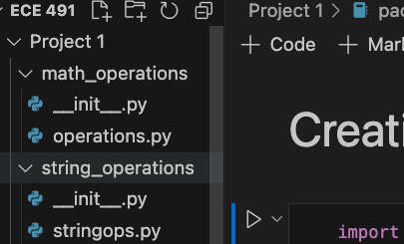*Figure 53: Package creation: Folder structure*

Next, three functions were created within the *`stringops.py`* module. Figure 54 shows the code within the file. The *`reverse_string`* function returns a reversed string. The *`count_vowels`* function uses a *`for`* loop to iterate over each letter in the received string. Then an *`if`* statement is used to determine if the letter is contained within the *`vowels`* string. If there is a match, then the variable *`count`* increases by one. This function returns the number of vowels in a word. The last function *`is_palindrome`* was copied from my previous examples. This function simply reverses the word and returns whether or not the string is the same backwards and forwards.

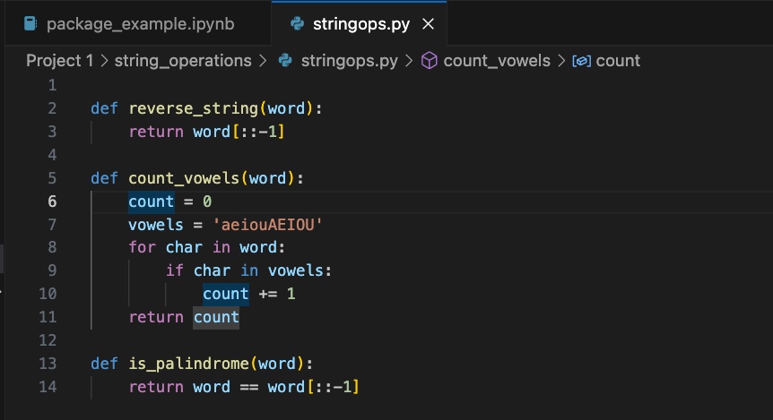*Figure 54: Package creation: Functions within `stringops.py`*

Finally, within a Jupyter Notebook, *`sys`* was imported and the package directory for *`string_operations`* was added. Using the *`from...import *`*, all functions from *`string_operations.stringops`* were imported into the notebook. Each function was called and the string variable *`x`* was passed to each one. The result of each function was printed to the screen. Figure 55 shows the code included in the notebook along with the resulting output after execution.

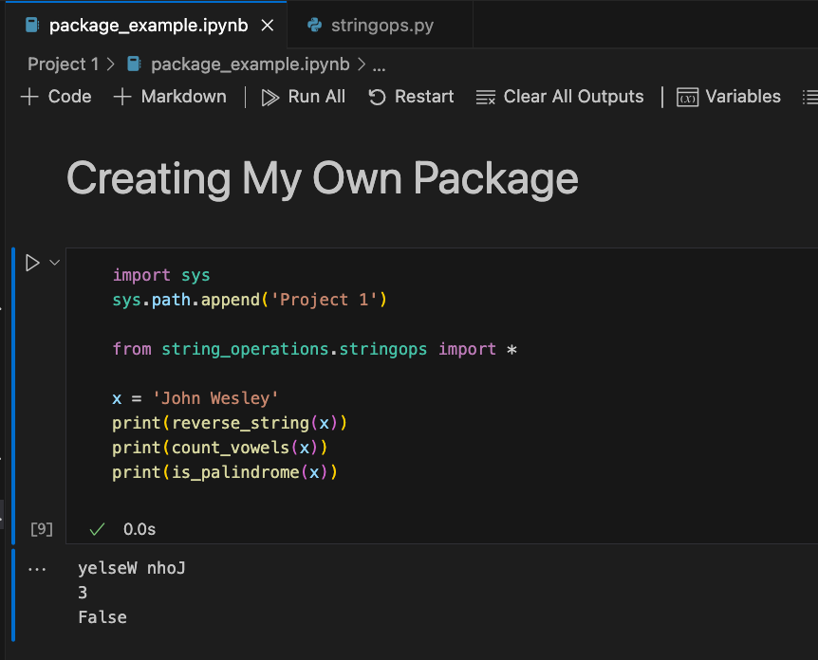*Figure 55: Package creation: Final code and output*

# 17. Strings and Regular Expressions

Figure 56 shows an example to demonstrate various methods that can be used to manipulate and format strings. My example allows the user to input a word or a sentence any way they would like. The sentence is then printed to the screen along with the various modifications applied to the word or sentence. In the example, the string ‘thE miScHieVoUs PurPle PlaTypUs PirouetTed aCrosS The ShImmerIng EmERalD pOND.’ is entered by the user.

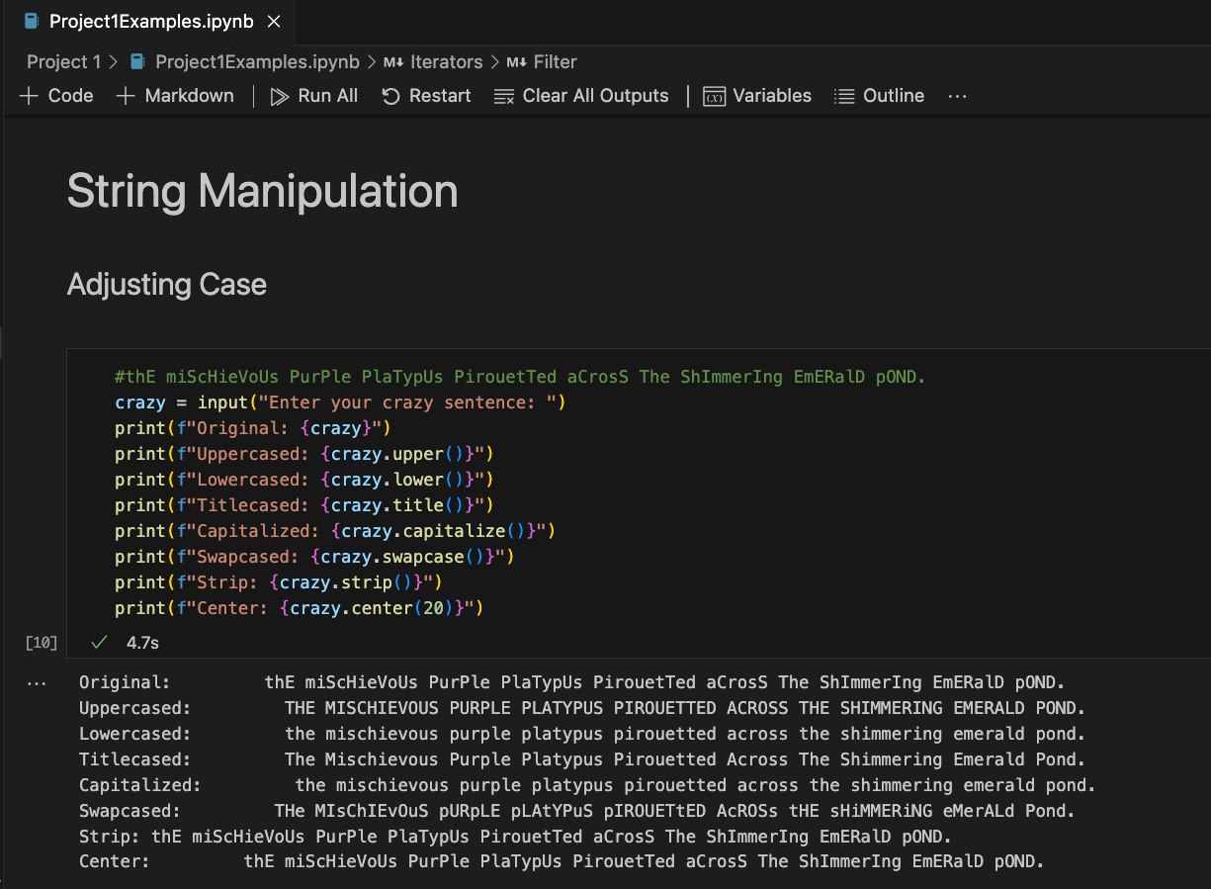*Figure 56.String manipulation code and output*

Figure 57 shows an example of how to find and replace information in a given string. A string named *`food`* is defined stating my favorite food. Various string methods are then used to find the starting position of the word ‘sushi’. I determine if the sentence ends with the word ‘pizza’. Lastly, I update the *`food`* string by replacing ‘sushi’ with ‘burrito’, printing the new string to the screen, and then replacing all instances of ‘r’ in the string with a ‘w’, and printing the result.

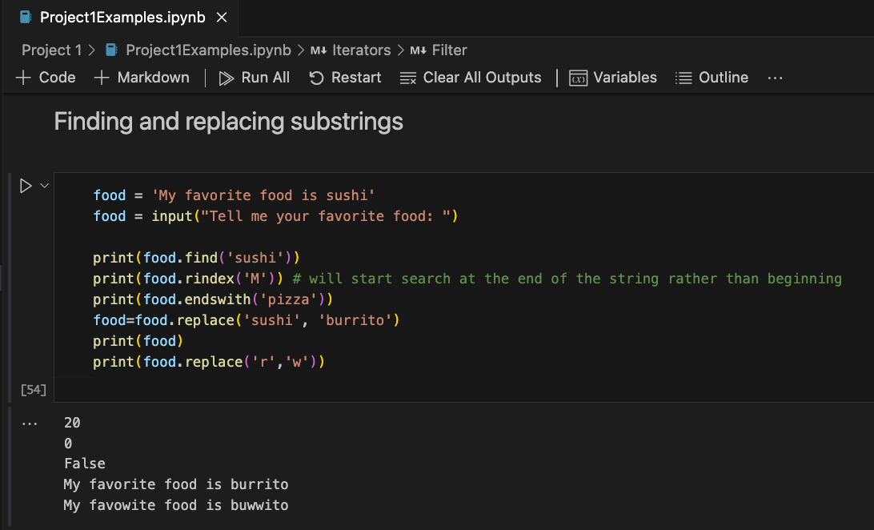*Figure 57.Find and replace string manipulation code and output*

Figure 58 shows simple code to demonstrate how the *`partition`* and *`split`* methods work on strings. The last snippet of code in the example is a quick program that takes in a user inputted sentence and stores the input in a variable named *`line`*. The user is then prompted to enter a split-point that they would like to split the sentence. The sentence is then split at the specified split-point. In the example the sentence inputted by the user is ‘Juggling flaming pineapples while riding a unicycle through a rainstorm of confetti and glitter’ and the split point entered is the letter ‘l’.

The last Python script analyzes the contents of a provided text file using regular expressions. Figure 59 shows the completed code. It first imports the *`re`* module for regular expression operations. Two functions are defined. The first one, `count_words(text)`, is used to count the number of words in a provided text file. The other function, *`extract_emails`*, is used to find and extract email addresses from the file, if there are any, based on the regex pattern. The regex pattern used here starts with a word boundary, *`\b`*, to be sure the email address is a separate word and not a part of a longer string. The next part, *`[A-Za-z0-9._%+-]+`*, is used to match the user name of the email address before the symbol, ‘@’. The next part of the regex expression matches the literal ‘@’ in the email address. Similar to matching the user name, *`[A-Za-z0-9._%+-]+`* is used to match the domain name. After matching the domain name, the regex expression matches the literal dot, ‘.’, in an email address. Lastly, *`[A-Z|a-z|]{3}`* matches the top level domain part of the email address, before finishing with another word boundary. Rather than use the *`open`* function to handle files, a *`with...as...`* block is used to open and read the text file to simplify the code and make it easier to read and the code cleaner. Once the text file has been read, its contents are stored in a variable named *`text`*. The *`count_words(text)`* and *`extract_emails(text)`* functions are applied to the *`text`* variable and the results stored in variables named *`word_count`* and *`emails`*. The results are printed to the screen. Before closing the file, the variable *`text`* holding the content of the text file is printed to the screen using an iterator and string manipulation to fit the text on the screen to provide visual confirmation of the results. Figure 60 displays the output of the program after execution.

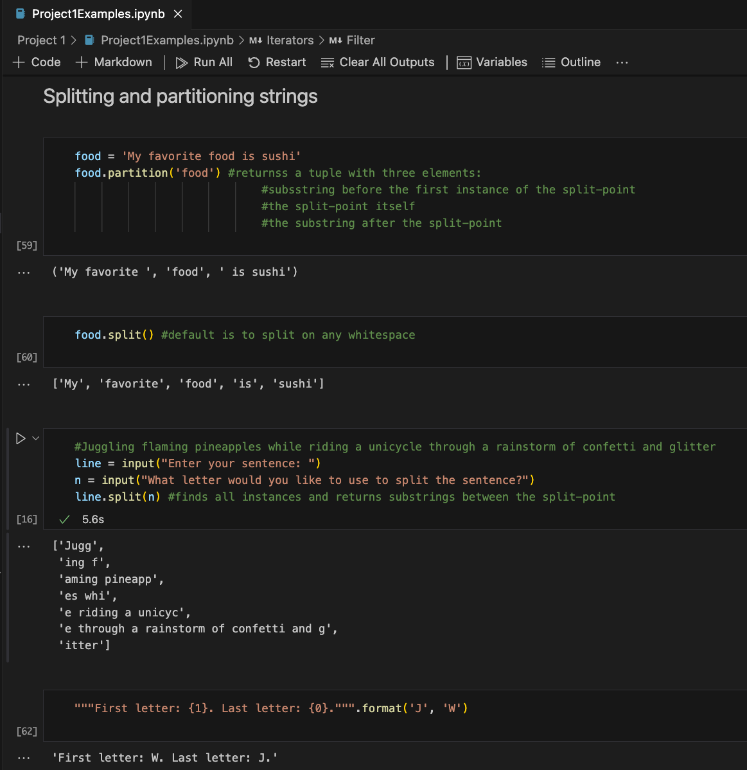*Figure 58.`Split` and `Partition` methods code and output*

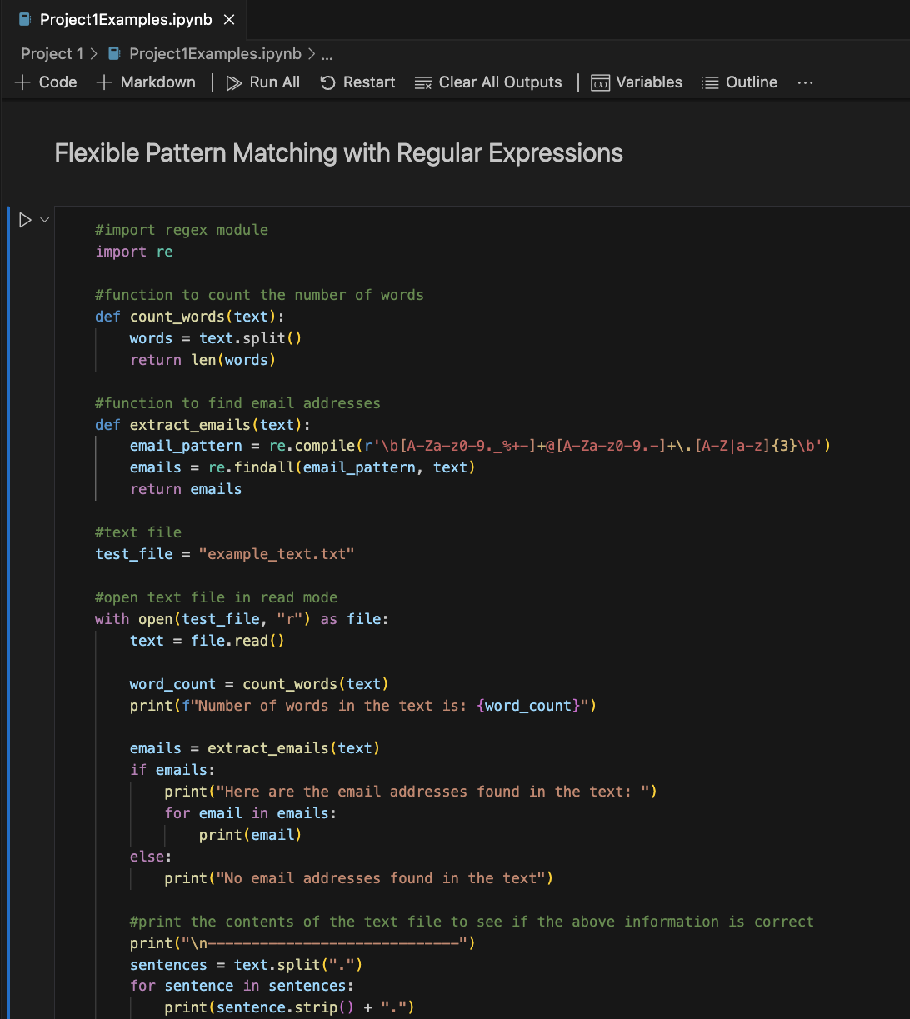*Figure 59.Regular Expressions code*

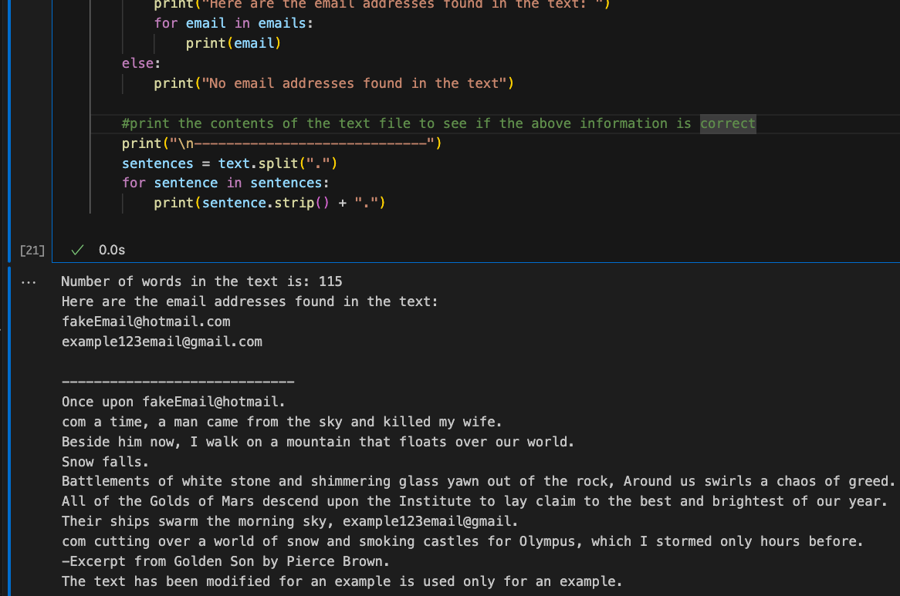*Figure 60.Regular expression output*

# **18. Conclusion**

This report documents my learning progress with basic Python syntax, semantics, and functionality. Four projects were coded and tested to demonstrate the fundamentals of Python programming. The examples attempt to show the use cases of the language and provide demonstration of my proficiency in using functions, data structures, control flow statements, iterators and much more. Through the process of coding, many errors were encountered. Due to the simplicity of the projects and exercises, all of the errors were syntax errors. My experience is mainly in C and C++ so I am used to the nuance of adding semicolons to the end of each line. Many times in Python, I found myself accidentally adding semicolons to the ends of blocks and statements, confused why my code block continually showed errors. Other examples of syntax errors I encountered include forget a quotation, forgetting a colon when defining a function or loop, or simply misspelling a variable that I named.

Using the Jupyter Notebook extension in VS Code really made the experience of learning Python interactive. However, there were some bugs in using the extension. For example, many times when running a code block, there was a delay in displaying output to the screen after receiving input. However, being able to incorporate live code, text, and documentation together provides a powerful tool for learning and collaborating. Using Jupyter Notebooks has helped me to grasp Python concepts by enabling me to simply use markdown to write notes and explanations with my live code. This helped me to grow familiar with the functionality of Jupyter Notebooks.

Creating the mini-projects and working through the exercises has helped me in taking the theory of Python fundamentals and put the concepts into practice and think about practical applications. This has allowed me to grasp the concepts that make Python a unique language. Using these concepts learned in *"A Whirlwind Tour of Python"* (VanderPlas, 2016), I hope to become more proficient in Python tools for data science and scientific computing over the next few weeks of taking this course.

# References

VanderPlas, J. (2016).  *Python Data Science Handbook*. GitHub repository. Retrieved May 26, 2024, from https://github.com/jakevdp/WhirlwindTourOfPython